Lesson 8 – Questions and Answers

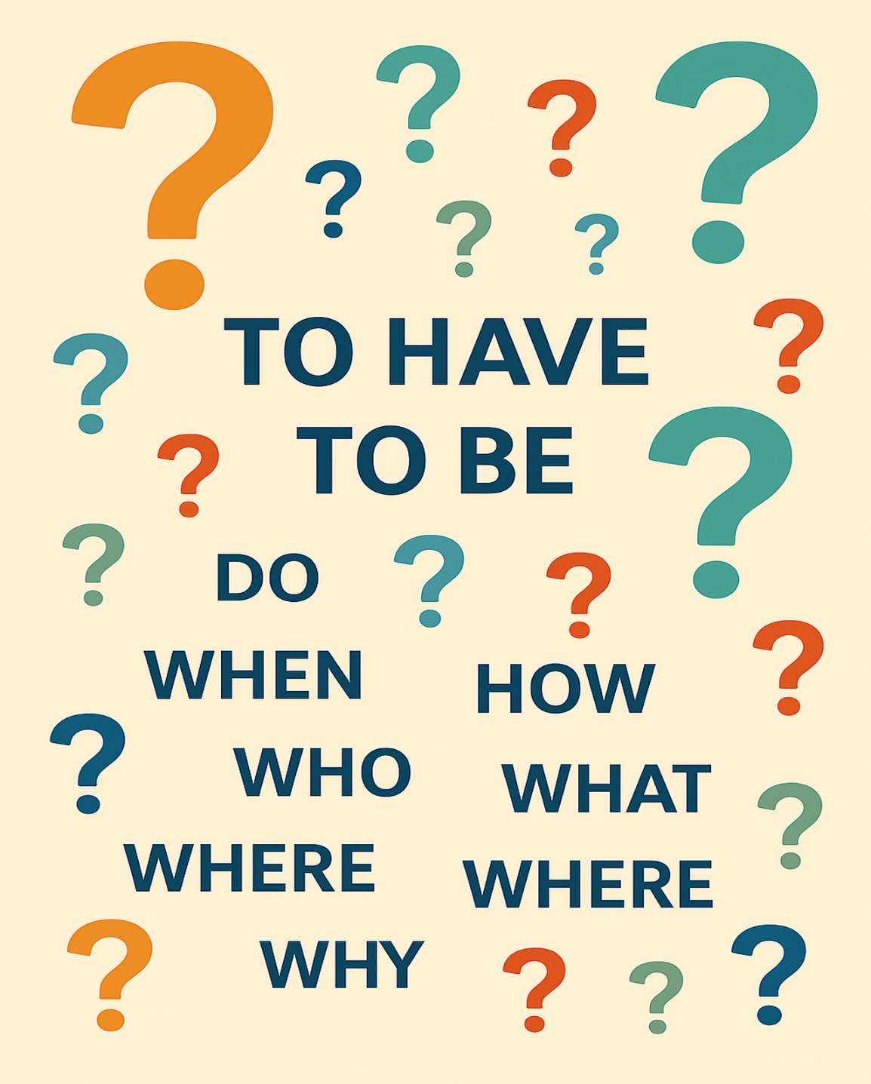

Name: _____________________________________

Date: ______________________________________

Lesson 8 Vocabulary Words

- Response
- Complete
- Question
- Pronoun
- Questionnaire
- Statement
- Application
- Information
- Verb
- Punctuation

Review: I Am, You Have (Verbs “To Have” and “To Be”)
Pronouns
I = one person (me)
You = one person
He = one male
She = one female
We = more than one person (including me)
They = more than one person

Examples:

- I am a woman. The flowers in my garden are pretty.
Single, in this case female
- You are a new student. Welcome to the class. ____________________________________
- He is sad. His mother will make him feel better. _________________________________
- She is thirsty. It’s time for a drink. _______________________________________________
- We are enjoying the warm weather. We like the sun. _____________________________
- You are human beings. You all deserve respect. __________________________________
- They are eating pizza. They like pepperoni on their pizza. _________________________

- I have grey hair. The colour is perfect for me. ___________________________________
- You have honey on your toast. Your fingers are sticky. ____________________________
- She has two quarters, a dime and a loonie. She has $1.60. ________________________
- He has to get ready for English class. He likes to learn. ____________________________
- We have a big problem. The bakery has no bread. _______________________________
- You have an hour to work on this project. You all need to be finished by then.
__________________________________
- They have learned about the weather. They know there are four seasons.
__________________________________

Comprehension Questions – I Am, You Have

Fill in the missing words.

- ______________________ is my name. (Student’s own name)
- _______________ (Me, I) have ___________________ (colour of) hair.
- You __________________ learning to speak English. (are, is)
- ________________ needs to buy a new car. (She, He) His car is old.
- She has a scraped knee. _______________ mother put a bandage on it. (They, Her)
- ____________ (Us, We) have to eat the cake. My sister made it for__________. (we, us)
- They _____________ (have, has) boxes full of pencils, erasers, and calculators.

Story: Ben and Jen Go to the Movies

One sunny afternoon, Ben asked Jen if she wanted to go to the movies with him that evening.
He asked, “Would you like to come to the movies with me?”
Yes, I would like to go with you. Do you have enough money?” Jen answered.
Ben looked for his wallet in his back pocket, but it wasn’t there. He checked all his pockets but became a little nervous when he couldn’t find it.
“Have you seen my wallet?” asked Ben. “I had it this morning.”
Jen quickly looked around the kitchen but did not see it. “Too bad it doesn’t ring like your phone does. When you lose that, I call your phone number.” Jen had started laughing.
Just then, Jill came home from her friend’s house around the corner. “I just found Dad’s wallet on the front step. Did he lose it again?” She put the wallet on the kitchen counter beside the coffee maker.
Ben walked across the kitchen to the counter. “I have three $5 bills and a 10$ bill. That should be enough if we don’t buy too many snacks.” He smiled at Jen.
Ben and Jen went to the movies. As they watched a movie about a huge blizzard, Ben fell asleep. The family in the movie got snowed in, and were running out of food. In the end, the people were saved. As they walked home, Jen thanked Ben for inviting her to the movies.
She also said, “I really enjoyed that movie. It was scary, and I was afraid they wouldn’t get out from under all that snow. But then I was excited when the farmers came from the west and rescued them.”
Ben was confused. “Who called the farmers? What did they use to move all that snow? When did the family get snowed in? Where did all that snow come from? Why didn’t they bring more food? How do you think they got them out?” Ben had a lot of questions. He missed the whole movie because he was sleeping.

Comprehension Questions – Story – Ben and Jen go to the Movies

- Circle Y for yes and N for no.
- Write a full sentence to answer the questions.

Example: Do you know where the hospital is? Y N
Yes, I know where the hospital is. It is on Pine Street.

1. Did Ben lose his phone? Y N

2. Was Jill at her friend’s house? Y N

3. Was the movie about some farmers who got stuck in a snowstorm? Y N

4. Did the farmers come from the east? Y N

5. Was it Jane who found Ben’s wallet? Y N

Story 2 - Ben and Jen Go to the Movies (2)
One sunny afternoon, Ben asked Jen to go to the movies.
He said, “Do you want to come to the movies with me?”
“Yes! I want to go,” said Jen.
“Do you have enough money?” she asked.
Ben looked for his wallet.
It was not in his back pocket.
He checked all his pockets.
He became a little nervous.
“Have you seen my wallet?” Ben asked.
“I had it this morning.”
Jen looked around the kitchen.
She did not see it.
She said, “Too bad it doesn’t ring like your phone.
When you lose your phone, I call your number.”
Jen laughed.
Just then, Jill came home from her friend’s house.
“I found Dad’s wallet on the front step,” she said.
She put the wallet on the kitchen counter.
Ben walked to the counter.
“I have three $5 bills and a $10 bill.
That is enough if we do not buy too many snacks,” he said.
He smiled at Jen.
Ben and Jen went to the movies.
They watched a movie about a big snowstorm.
The family in the movie got trapped in the snow.
They were running out of food.
At the end, the people were saved.
As they walked home, Jen thanked Ben.
“I liked the movie,” she said.
“It was scary. I was afraid the family would stay under the snow.
But I was happy when farmers came and rescued them.”
Ben was confused.
He asked many questions:
“Who called the farmers?
What did they use to move the snow?
When did the family get trapped?
Where did all the snow come from?
Why didn’t they bring more food?
How did they get out?”

Comprehension Questions – Story 2 - Ben and Jen Go to the Movies (2)

- Circle Y for yes and N for no.
- Write a full sentence to answer the questions.

Example: Do you know where the hospital is? Y N
Yes, I know where the hospital is. It is on Pine Street.

- Who asked whom to go to the movies?

- Where did Jill find Ben’s wallet?

- How much money did Ben have for the movie?

- What happened to the family in the movie?

- How did Jen feel at the end of the movie?

What might be the question to these answers? There could be more than one right question.

- It's cold outside, and the leaves have fallen off the trees. ________________________________________

- I am very well, thank you. ____________________________________________________________________

- We listen with our ears. ______________________________________________________________________

- They live at 123 Fourth Street. ________________________________________________________________

- He is the father of my mother. ________________________________________________________________

- Hello. Nice to meet you. _____________________________________________________________________

- I was born on June 6, 1986. _________________________________________________________________

- It is red, has 8 sides and tells drivers what they should do. ______________________________________

- There is so much snow falling today. _________________________________________________________

- It is the season between winter and summer. __________________________________________________

- Polar bears live way up here. ________________________________________________________________

- She has to buy meat to cook for supper. _______________________________________________________

- It's where I leave my car when I go to the store. ________________________________________________

- It opens up to protect you from wet weather. ___________________________________________________

- My cat ran away, and I have tears on my face. ________________________________________________

- Linda ate three servings of chicken noodle soup. ______________________________________________

- I have a candy in my hands. _________________________________________________________________

- It keeps loose papers together. ______________________________________________________________

- It is 3:15 p.m. _______________________________________________________________________________

- We will have turkey and vegetables at 6:00 p.m. _______________________________________________

