Lesson 8 – Questions and Answers

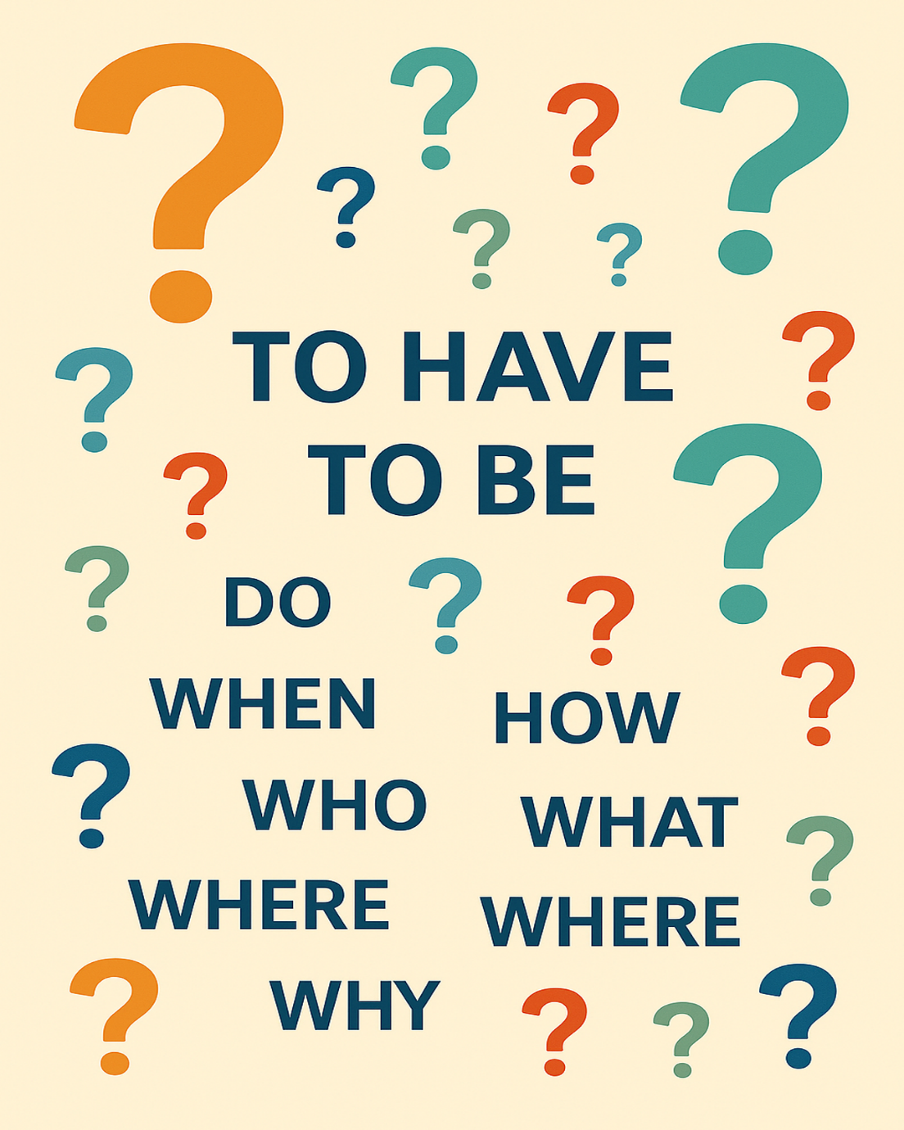

Name: ____________________

Date: ______________________

Lesson 8 Vocabulary Words

- Response
- Complete
- Question
- Pronoun
- Questionnaire
- Statement
- Application
- Information
- Verb
- Punctuation

Review: I Am, You Have (Verbs “To Have” and “To Be”)
Pronouns
I = one person (me)
You = one person
He = one male
She = one female
We = more than one person (including me)
They = more than one person

Examples:

- I am a woman. The flowers in my garden are pretty.
Single, in this case female
- You are a new student. Welcome to the class.
Click or tap here to enter text.
- He is sad. His mother will make him feel better.
Click or tap here to enter text.
- She is thirsty. It’s time for a drink.
Click or tap here to enter text.
- We are enjoying the warm weather. We like the sun. Click or tap here to enter text.
- You are human beings. You all deserve respect. Click or tap here to enter text.
- They are eating pizza. They like pepperoni on their pizza. Click or tap here to enter text.

- I have grey hair. The colour is perfect for me. Click or tap here to enter text.
- You have honey on your toast. Your fingers are sticky. Click or tap here to enter text.
- She has two quarters, a dime and a loonie. She has $1.60. Click or tap here to enter text.
- He has to get ready for English class. He likes to learn. Click or tap here to enter text.
- We have a big problem. The bakery has no bread. Click or tap here to enter text.
- You have an hour to work on this project. You all need to be finished by then.
Click or tap here to enter text.
- They have learned about the weather. They know there are four seasons.
Click or tap here to enter text.

Comprehension Questions – I Am, You Have

Fill in the missing words.

- Click or tap here to enter text.is my name. (Student’s own name)
- Click or tap here to enter text. (Me, I) have Click or tap here to enter text. (colour of) hair.
- You Click or tap here to enter text. learning to speak English. (are, is)
- Click or tap here to enter text. needs to buy a new car. (She, He) His car is old.
- She has a scraped knee. Click or tap here to enter text.mother put a bandage on it. (They, Her)
- Click or tap here to enter text.(Us, We) have to eat the cake. My sister made it forClick or tap here to enter text.. (we, us)
- They Click or tap here to enter text. (have, has) boxes full of pencils, erasers, and calculators.

Story: Ben and Jen Go to the Movies

One sunny afternoon, Ben asked Jen if she wanted to go to the movies with him that evening.
He asked, “Would you like to come to the movies with me?”
Yes, I would like to go with you. Do you have enough money?” Jen answered.
Ben looked for his wallet in his back pocket, but it wasn’t there. He checked all his pockets but became a little nervous when he couldn’t find it.
“Have you seen my wallet?” asked Ben. “I had it this morning.”
Jen quickly looked around the kitchen but did not see it. “Too bad it doesn’t ring like your phone does. When you lose that, I call your phone number.” Jen had started laughing.
Just then, Jill came home from her friend’s house around the corner. “I just found Dad’s wallet on the front step. Did he lose it again?” She put the wallet on the kitchen counter beside the coffee maker.
Ben walked across the kitchen to the counter. “I have three $5 bills and a 10$ bill. That should be enough if we don’t buy too many snacks.” He smiled at Jen.
Ben and Jen went to the movies. As they watched a movie about a huge blizzard, Ben fell asleep. The family in the movie got snowed in, and were running out of food. In the end, the people were saved. As they walked home, Jen thanked Ben for inviting her to the movies.
She also said, “I really enjoyed that movie. It was scary, and I was afraid they wouldn’t get out from under all that snow. But then I was excited when the farmers came from the west and rescued them.”
Ben was confused. “Who called the farmers? What did they use to move all that snow? When did the family get snowed in? Where did all that snow come from? Why didn’t they bring more food? How do you think they got them out?” Ben had a lot of questions. He missed the whole movie because he was sleeping.

Comprehension Questions – Story – Ben and Jen go to the Movies

- Check Y for yes and N for no.
- Write a full sentence to answer the questions.

Example: Do you know where the hospital is? ☒ Y ☐ N
Yes, I know where the hospital is. It is on Pine Street.

1. Did Ben lose his phone? ☐ Y ☐ N

2. Was Jill at her friend’s house? ☐ Y ☐ N

3. Was the movie about some farmers who got stuck in a snowstorm? ☐ Y ☐ N

4. Did the farmers come from the east? ☐ Y ☐ N

5. Was it Jane who found Ben’s wallet? ☐Y ☐ N

Story 2 - Ben and Jen Go to the Movies (2)
One sunny afternoon, Ben asked Jen to go to the movies.
He said, “Do you want to come to the movies with me?”
“Yes! I want to go,” said Jen.
“Do you have enough money?” she asked.
Ben looked for his wallet.
It was not in his back pocket.
He checked all his pockets.
He became a little nervous.
“Have you seen my wallet?” Ben asked.
“I had it this morning.”
Jen looked around the kitchen.
She did not see it.
She said, “Too bad it doesn’t ring like your phone.
When you lose your phone, I call your number.”
Jen laughed.
Just then, Jill came home from her friend’s house.
“I found Dad’s wallet on the front step,” she said.
She put the wallet on the kitchen counter.
Ben walked to the counter.
“I have three $5 bills and a $10 bill.
That is enough if we do not buy too many snacks,” he said.
He smiled at Jen.
Ben and Jen went to the movies.
They watched a movie about a big snowstorm.
The family in the movie got trapped in the snow.
They were running out of food.
At the end, the people were saved.
As they walked home, Jen thanked Ben.
“I liked the movie,” she said.
“It was scary. I was afraid the family would stay under the snow.
But I was happy when farmers came and rescued them.”
Ben was confused.
He asked many questions:
“Who called the farmers?
What did they use to move the snow?
When did the family get trapped?
Where did all the snow come from?
Why didn’t they bring more food?
How did they get out?”

Comprehension Questions – Story 2 - Ben and Jen Go to the Movies (2)

- Check Y for yes and N for no.
- Write a full sentence to answer the questions.

Example: Do you know where the hospital is? ☒ Y ☐ N
Yes, I know where the hospital is. It is on Pine Street.

- Who asked whom to go to the movies?

- Where did Jill find Ben’s wallet?

- How much money did Ben have for the movie?

- What happened to the family in the movie?

- How did Jen feel at the end of the movie?

What might be the question to these answers? There could be more than one right question.

- It's cold outside, and the leaves have fallen off the trees. Click or tap here to enter text.

- I am very well, thank you. Click or tap here to enter text.

- We listen with our ears. Click or tap here to enter text.

- They live at 123 Fourth Street. Click or tap here to enter text.

- He is the father of my mother. Click or tap here to enter text.

- Hello. Nice to meet you. Click or tap here to enter text.

- I was born on June 6, 1986. Click or tap here to enter text.

- It is red, has 8 sides and tells drivers what they should do. Click or tap here to enter text.

- There is so much snow falling today. Click or tap here to enter text.

- It is the season between winter and summer. Click or tap here to enter text.

- Polar bears live way up here. Click or tap here to enter text.

- She has to buy meat to cook for supper. Click or tap here to enter text.

- It's where I leave my car when I go to the store. Click or tap here to enter text.

- It opens up to protect you from wet weather. Click or tap here to enter text.

- My cat ran away, and I have tears on my face. Click or tap here to enter text.

- Linda ate three servings of chicken noodle soup. Click or tap here to enter text.

- I have a candy in my hands. Click or tap here to enter text.

- It keeps loose papers together. Click or tap here to enter text.

- It is 3:15 p.m. Click or tap here to enter text.

- We will have turkey and vegetables at 6:00 p.m. Click or tap here to enter text.

