Functional English

Lesson 7

Homework Assignment

Name: Click or tap here to enter text.
Date:Click or tap here to enter text.

Homework Instructions

Please complete Questions 1–11 before next week’s class.

How to Complete the Homework
- Read each question carefully
- Type your answers directly into this document where it says “Click or tap here to enter text.”
- Answer all comprehension questions and writing tasks
- Try your best. Use full sentences where possible, especially for the writing tasks
- You may use a calculator, dictionary or translator if needed

How to Submit Your Homework
- Save the completed document
- Email the document to your instructor before next week’s class
- Make sure your name is on the document or in the email subject line

If you have questions or need help, please contact your instructor.
Do your best—we will review the work together in class!

Question 1: Independent Assignment

Go through your house and see how many different items you can find in each room. Using this chart, fill in the name of the room. Find five things in that room that typically belong there. Do this for three different rooms. You can decide which three rooms you examine.

Room | Objects
Click or tap here to enter text. | Click or tap here to enter text.
Click or tap here to enter text. | Click or tap here to enter text.
Click or tap here to enter text. | Click or tap here to enter text.

Question 2: Rooms in a House
Kitchen
Living room
Bedroom
Bathroom
Laundry room
Dining room
Home office
Basement
Stairs

This house has many rooms you may also have in your house. Label each room.

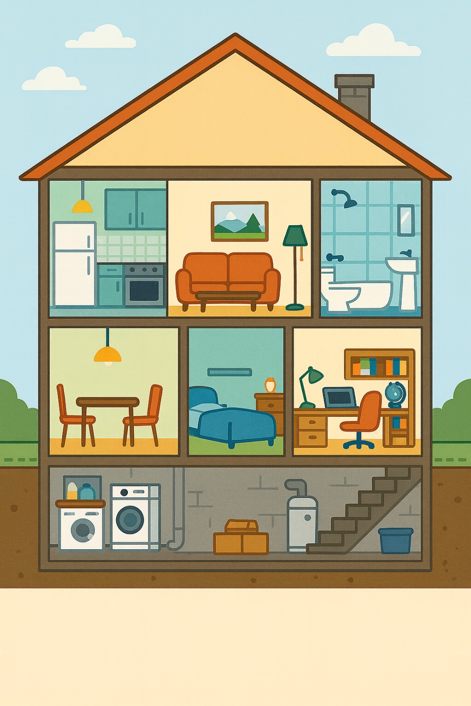

Click or tap here to enter text.

Click or tap here to enter text.
Click or tap here to enter text.

Click or tap here to enter text. Click or tap here to enter text.

Click or tap here to enter text.

Click or tap here to enter text. Click or tap here to enter text.

Click or tap here to enter text.

Question 3: The Classroom
Desk
Chair
Table
Photocopier
Pencils
Scissors
Bookshelf
Laptop
Flag
Blackboard
Clock

This is a classroom. When we come to school, we might see some of these objects.
Please label each image with the words from the list.


Click or tap here to enter text.

Click or tap here to enter text.

Click or tap here to enter text. Click or tap here to enter text.

Click or tap here to enter text.
Click or tap here to enter text.
Click or tap here to enter text.
Click or tap here to enter text.

Click or tap here to enter text. Click or tap here to enter text.

Click or tap here to enter text.

Question 4: Math Practice- Fuel Costs

Scenario: A car needs to be filled with gasoline. It will hold 40 litres.
Gas Station | Price per Litre
Station A | $1.60
Station B | $1.55
http://www.freepik.com/
Designed by pch.vector

Questions:
- How much will it cost at Station A?

Click or tap here to enter text.

- How much will it cost at Station B?

Click or tap here to enter text.

- How much money do you save if you go to Station B?

Click or tap here to enter text.

- You give the cashier $70 at Station B. How much change should you get?

Click or tap here to enter text.

- How could the cashier give the change using bills and coins?

Click or tap here to enter text.

Question 5: Math Practice- Making Change
How many bills and coins are needed to show the correct change.


Using the money available in the cash drawer and make the following amounts:
1.  $12.60  Click or tap here to enter text. | 2.  $24.75  Click or tap here to enter text.
3.  $22.35  Click or tap here to enter text. | 4.  $37.30  Click or tap here to enter text.
5.  $41.05  Click or tap here to enter text. | 6.  $46.90  Click or tap here to enter text.

Question 6: Seasons in the North
Read the story Seasons in the North and answer the Comprehension Questions and complete the Writing Task.

Seasons in the North
Northeastern Ontario has four seasons.
Winter is cold. There is a lot of snow.
Spring is warm and rainy.
Summer is hot and sunny.
Fall is cool. The leaves change colour.
People do different things in each season. In winter, they skate and ski. In summer, they swim and go camping.
Comprehension Questions (Try to write a full sentence.)
  - How many seasons are there?

Click or tap here to enter text.

  - What is winter like?

Click or tap here to enter text.

  - What do people do in summer?

Click or tap here to enter text.

  - Which season has leaves changing colour?

Click or tap here to enter text.

Writing Prompt
Write 1 - 2 sentences about your favourite season and why.
Click or tap here to enter text.
Question 7: Seasons in Northeastern Ontario
Read the story Seasons in Northeastern Ontario (It is a little harder than Seasons in the North) and answer the Comprehension Questions and Writing Prompt.

Seasons in Northeastern Ontario
In Northeastern Ontario, the year is divided into four seasons: winter, spring, summer, and fall.
Winter is cold and snowy. People enjoy skating, skiing, and snowmobiling. Some people snowshoe in the wintertime.
Spring brings warmer weather and rain, which helps plants grow.
Summer is hot and sunny, a good time for swimming, camping, and fishing.
Fall is cooler. The leaves on the trees turn red, yellow, and orange before they fall.

Comprehension Questions
- Name all four seasons in Northeastern Ontario.

Click or tap here to enter text.
- Name one winter activity you would like to try and why?

Click or tap here to enter text.
- How does spring help plants?

Click or tap here to enter text.
- What happens to the leaves in the fall?

Click or tap here to enter text.
- What season is best for swimming?

Click or tap here to enter text.
Writing Prompt
Write 3–4 sentences: Describe one thing would like to do in your favourite season.
Click or tap here to enter text.

Question 8: The Four Seasons of Northeastern Ontario
Read the story The Four Seasons of Northern Ontario (It is a little harder than Seasons of Northeastern Ontario) and answer the Comprehension Questions and Writing Prompt.
The Four Seasons of Northeastern Ontario

Northeastern Ontario experiences four distinct seasons, each with its own weather and activities.
Winter is long, cold, and snowy, making it ideal for snowmobiling, skiing, and ice fishing. Spring brings warmer temperatures and rainfall, which melt the snow and allow plants and trees to grow again.
Summer is hot and sunny, offering perfect conditions for camping, swimming, boating, and hiking. Fall is cool and crisp. The leaves change to bright reds, oranges, and yellows before dropping, creating beautiful scenery.
The changing seasons shape life in the region, from outdoor recreation to the types of work available. For example, tourism peaks in both summer and winter because of the wide range of activities.

Comprehension Questions
- How does spring change the land after winter?

Click or tap here to enter text.

- Why might tourism be busy in both summer and winter?

Click or tap here to enter text.

- Describe the weather in fall?

Click or tap here to enter text.

- Which season would be best for someone who likes boating? Why?

Click or tap here to enter text.

- How do the seasons affect life in the region?

Click or tap here to enter text.
Writing Prompt
Write a paragraph about your least favourite season. Include what the weather is like, and why you do not like it.
Click or tap here to enter text.
Question 9: Recycling
Read the story Recycling and answer the Comprehension Questions and Writing Prompt.

Recycling
People in Northeastern Ontario recycle to help the Earth.
They recycle paper, plastic, and cans.
Trash goes in the garbage.
Some towns have special bins for recycling.
Recycling helps keep the community clean.

Comprehension Questions
- Name two things you can recycle.

Click or tap here to enter text.
- Where do you put trash?

Click or tap here to enter text.
- Why should people recycle?

Click or tap here to enter text.
- What is a bin used for?

Click or tap here to enter text.

Writing Prompt
Write 1–2 sentences: How do you help with recycling at home?

Click or tap here to enter text.

Question 10: Recycling and Waste Disposal
Read the story Recycling and Waste Disposal (It is a little harder than Recycling)
and answer the Comprehension Questions and Writing Prompt.

Recycling and Waste Disposal
In Northeastern Ontario, recycling is important to protect the environment. People sort paper, plastic, metal, and glass into recycling bins. Other waste goes into garbage bins.
Some items, like batteries and electronics, must be taken to special drop-off locations. Recycling reduces pollution, saves resources, and helps the community stay clean.

Comprehension Questions
- Name four types of materials that can be recycled.

Click or tap here to enter text.
- Where should batteries and electronics go?

Click or tap here to enter text.
- How does recycling help the environment?

Click or tap here to enter text.
- Why is it important to sort waste?

Click or tap here to enter text.
- Give one reason why recycling is helpful for the community.

Click or tap here to enter text.
Writing Prompt
Write 3–4 sentences: Describe how you sort trash and recycling at home. Why is it important?
Click or tap here to enter text.

Question 11: Recycling and Waste Disposal in Northeastern Ontario
Read the story Recycling and Waste Disposal in Northeastern Ontario (It is a little harder than Recycling and Waste Disposal) and answer the Comprehension Questions.

Recycling and Waste Disposal in Northeastern Ontario
Recycling and proper waste disposal are essential practices in Northeastern Ontario. Residents separate paper, cardboard, plastics, metals, and glass into designated recycling bins. Other items, such as food waste, go into compost bins or garbage bins.
Certain materials, including batteries, electronics, and hazardous waste, must be brought to special recycling depots. Recycling conserves natural resources, reduces pollution, and supports sustainability. Communities that practice effective waste management maintain cleaner neighbourhoods and protect local ecosystems.

Comprehension Questions
- Name five materials that can be recycled in Northeastern Ontario.

Click or tap here to enter text.
- What types of waste must go to special depots?

Click or tap here to enter text.
- How does recycling help conserve natural resources?

Click or tap here to enter text.
- Why is proper waste disposal important for local ecosystems?

Click or tap here to enter text.
- How does recycling support a cleaner community?

Click or tap here to enter text.
- Explain the difference between compost, recycling, and garbage.

Click or tap here to enter text.

Writing Prompt
Write a paragraph describing how your community handles recycling and waste disposal. Include the types of materials, how residents are involved, and why these practices are important.
Click or tap here to enter text.

