Lesson 7 – Home and Classroom

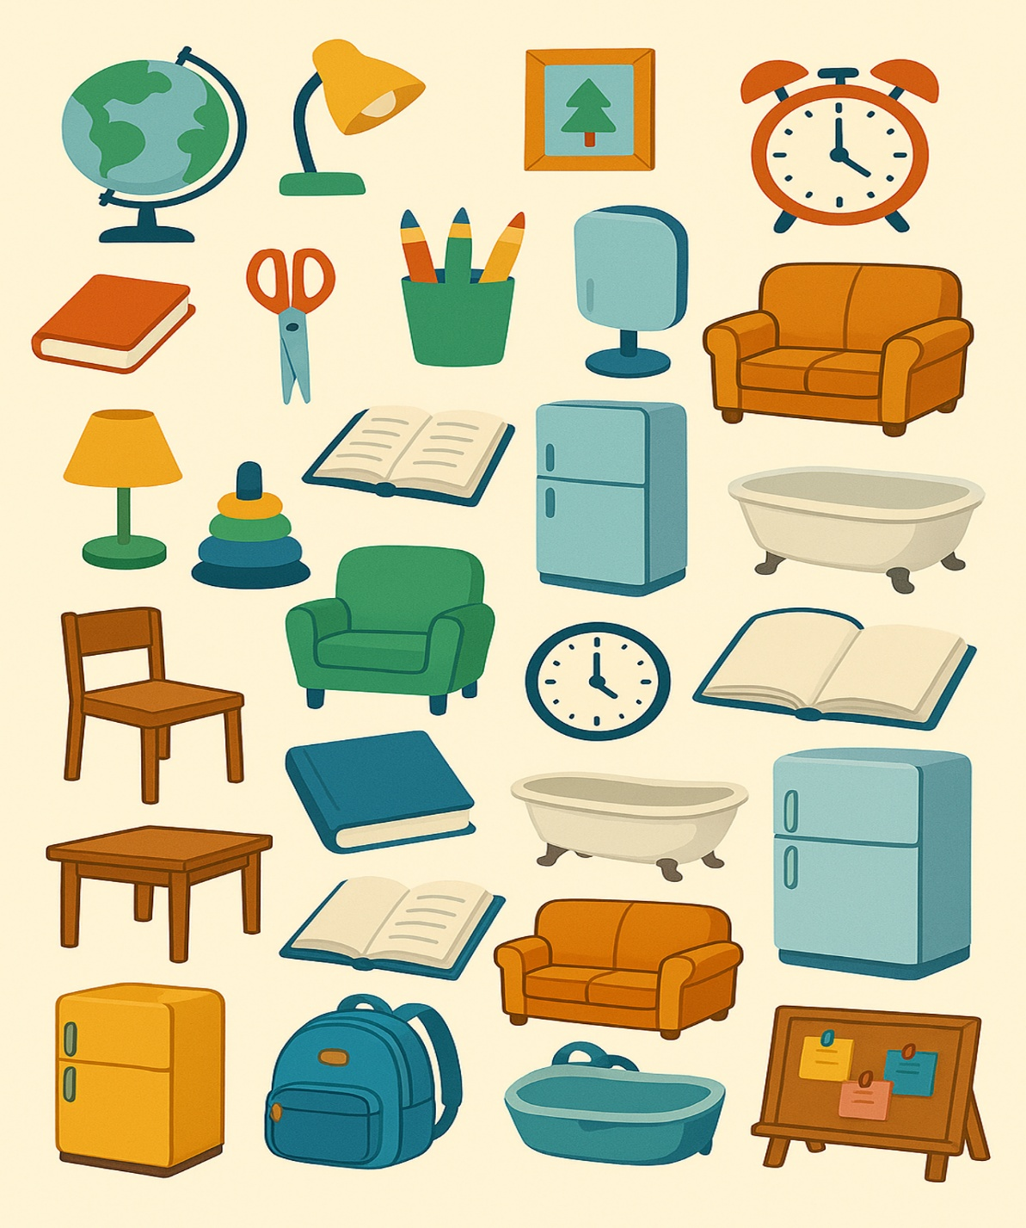

Name: _____________________________________

Date: ______________________________________
Lesson 7 Vocabulary Words

- Apartment building
- Duplex
- Schedule
- Attendance
- Subjects
- Kitchen
- Assessment
- Basement
- Window
- Closet
- Laptop
- Library

Story 1: Getting Ready for Grandmother
Jen has to clean the house today because Grandmother is coming to visit. She starts by getting all the dirty clothes and bringing them to the laundry room to wash them. She turns on the washing machine, which starts to fill with water. She adds the detergent. When all the clothes are in the machine, she closes the lid. She will come back later and put the clothes in the dryer. If it stays sunny, Jen will hang the clothes outside.
Jen asks her husband Ben to help her in the kitchen. Ben washes the dishes in the sink, while Jen dries the dishes and puts them away in the cupboard. She dries plates, bowls, and coffee cups. After she dries the spoons, knives, and forks, she puts them away in the drawer. Ben wipes the counter, the stove top, and all around the sink, faucet and taps.
Jen starts to sweep the floor while Ben gets the mop and bucket. He fills the bucket with hot water and floor cleaner. Ben likes clean floors. They shine when he is finished.
Next is the living room. Jen asks Jane and Jill to help her. Jane dusts the furniture with a rag and dust polish. She doesn’t like the smell of the polish. It makes her sneeze. Jill plugs in the vacuum and cleans the carpet. She also uses the smaller attachment and vacuums the sofa and the armchair. Now all of Max’s cat hair is cleaned up.
Jen looks in the guest bedroom and sees that Ben is putting clean sheets on the bed where Grandmother will sleep. Jill brought the vacuum to her dad. The carpet will be clean in here, too! Jill puts clean towels out for Grandmother.
The final room to clean is the bathroom. She sprays bathroom cleaner on the sink, taps and counter. She uses a clean cloth to wipe it off. She uses glass cleaner on the mirror. There is a lot of toothpaste splatter on the mirror. The toilet gets cleaned with a toilet brush and toilet bowl cleaner. Much better! The only thing left is the bathtub. Jen puts in the heater and runs some very hot water. She adds the tub cleaner, and it makes some bubbles. She gets down on her knees and gets the sponge wet in the hot, bubbly water. She scrubs the bottom and up the sides of the tub. While it soaks for a bit, Jen stands up and uses the wet cloth to wipe the fixtures and the tile. After draining and rinsing the tub, the bathroom is sparkling!
We are ready for Grandmother to come and visit our home.

Comprehension Questions – Story 1 – Getting Ready for Grandmother

- Grandmother is coming to visit. Name three things Jen did to get ready for her visit.

2. What did Ben do to help prepare for Grandmother’s visit? Answer: ___
a) Ben washed the car.
b) Ben did the laundry.
c) Ben washed the dishes.

3. Why doesn’t Jane like dusting the living room? Answer: ___
a) The dust makes her sneeze.
b) The dust polish makes her sad.
c) The dust polish makes her sneeze.

4. How many things did Jen clean in the bathroom? Answer: ___
a) The sink, tub, toilet, and mirror.
b) The sink, toilet, mirror, sofa and floor.
c) The sink, counter, mirror, tub, and toilet.

5. How do you know Jen and her family are ready for Grandmother to visit? Answer: ___
a) They bought all the groceries.
b) They cleaned the house.
c) They cleaned some of the house.

Getting Ready for Grandmother (2)
Jen has to clean the house today.
Grandmother is coming to visit.
Jen picks up all the dirty clothes.
She takes them to the laundry room.
She puts the clothes in the washing machine.
She adds soap and turns it on.
The machine fills with water.
Later, Jen will put the clothes in the dryer.
If it is sunny, she will hang them outside.
Jen asks her husband, Ben, to help.
Ben washes the dishes in the sink.
Jen dries the dishes and puts them away.
She dries plates, bowls, and cups.
She puts the spoons, forks, and knives in the drawer.
Ben wipes the counter and the stove.
Next, Jen sweeps the floor.
Ben gets the mop and bucket.
He fills the bucket with hot water and cleaner.
Ben likes clean floors.
They shine when he is done.
Now they clean the living room.
Jen asks Jane and Jill to help.
Jane dusts the tables and chairs.
The smell of the dust spray makes her sneeze.
Jill plugs in the vacuum.
She vacuums the carpet and the sofa.
Now all of Max the cat’s hair is gone.
In the guest room, Ben puts clean sheets on the bed.
Jill gives him the vacuum.
He cleans the carpet.
Jill puts clean towels on the bed for Grandmother.
Last, Jen cleans the bathroom.
She sprays cleaner on the sink and the counter.
She wipes it with a cloth.
She cleans the mirror and the toilet.
Then she washes the bathtub with hot, soapy water.
She scrubs and rinses it well.
Now the house is clean.
Jen and her family are ready for Grandmother to visit!

Comprehension Questions – Getting Ready for Grandmother (2)

- Who is coming to visit Jen’s house?

- What does Jen do with the dirty clothes?

- Who helps Jen wash and dry the dishes?

- What does Jill do in the living room?

5. How does Jen clean the bathtub?

Story 2: Ben Works at School

Ben has to go to work. He teaches high school geography. The walls in his classroom are covered with maps from different countries. He has a globe on his desk. When the students get to class, he asks them to find their textbooks on the bookshelf at the back of the room. When the students are all seated, Ben starts the lesson.
There are many other things in Ben’s classroom that you will find in almost any classroom. There is a whiteboard with dry-erase markers. There is also a blackboard with chalk. The windows don’t have curtains but have blinds instead.
On the wall by the classroom door, there is a pencil sharpener. The garbage or trash can is underneath the pencil sharpener to catch the mess that falls out.
There are two computers in the classroom, but Ben has his own laptop that he uses all the time. The classroom computers are on small desks at the side of the class. Each desk has a chair. The students have desks that are a bit bigger, but the chairs are all the same.
One of the shelves has baskets with school supplies in them. Ben has filled baskets with scissors, glue, markers, pencils, pens, pencil crayons, and rulers. There is also a stapler, a hole-punch, and a large stack of lined paper. You never know when you’re going to run out of paper!
Just outside the classroom door, the hallway is lined with lockers to keep your coat, boots, and books in. Jane and Jill do not have lockers at their school. They are too young. The lockers are locked, so no one can see what you have when you’re not there.
Ben also has some plants and a picture of his family on his desk. The students think Ben is a great teacher!

Comprehension Questions – Story 2 – Ben Works at School
1. What subject does Ben teach? Answer: ____
a) Geography
b) Mathematics
c) English

2. Where would you find the blinds? Answer: ____
a) On a desk
b) On a door
c) On a window

3. Name three types of school supplies that Ben has in the baskets.

4. What can you store in your locker? Answer: ___
a) Coat, boots, and cat
b) Boots, books, and ice cream
c) Books, boots, and coat

5. What was your favourite subject in school? Why?

Story 4 - Ben Works at School (2)
Ben has to go to work.
He is a teacher. He teaches high school geography.
The classroom has maps on the walls.
Ben has a globe on his desk.
When the students come to class,
Ben asks them to get their textbooks from the shelf.
When everyone is seated, Ben starts the lesson.
Ben’s classroom has many things you see in other classrooms.
There is a whiteboard with markers.
There is a blackboard with chalk.
The windows have blinds, not curtains.
Near the door is a pencil sharpener.
Under the sharpener is a trash can.
It catches the pencil shavings.
There are two computers in the room.
Ben has his own laptop.
The classroom computers are on small desks.
Each desk has a chair.
The students have bigger desks, but the chairs are the same.
One shelf has baskets with school supplies.
There are scissors, glue, markers, pencils, pens, and rulers.
There is also lined paper, a hole punch, and a stapler.
Outside the classroom, the hallway has lockers.
The lockers keep coats, boots, and books safe.
Jane and Jill do not have lockers. They are too young.
Ben has plants and a picture of his family on his desk.
The students think Ben is a great teacher!

Comprehension Questions – Story 2 – Ben Works at School (2)
- What subject does Ben teach?

- Where do the students get their textbooks?

- What is near the classroom door?

- What do the lockers in the hallway keep safe?

- What does Ben have on his desk besides a laptop?
First Impressions Words

Directions
- Work with a partner.
- Partner A chooses 5 words from List A: Classroom Words.
- Partner A says one word to Partner B.
- Partner B says the first word they think of.
  - Example:
    - Partner A says: computer
    - Partner B says: silver
- Write down Partner B’s word.
- Repeat until you have 5 word pairs.
- Switch roles.
- Use List B: Home Words and repeat steps 3–6.

Writing Activity
- When both partners finish, write 5 sentences using the word pairs.
- Example sentence:
- The silver computer is on the desk.
Use the word lists to help you write your sentences.

First Impressions Word Lists

Classroom-Related Words  List A |  | Home-Related Words  List B
Desk |  | Sofa
Chair |  | Bed
Table |  | Refrigerator
Blackboard |  | Dishwasher
Blinds |  | Oven
Scissors |  | Armchair
Textbooks |  | Shower
Bookshelf |  | Spatula
Schedule |  | Carpet
Calculator |  | Curtains

Name: ________________________ Partner: _____________________________

Word Given | Word that Comes to Mind

Sentences

1. ___________________________________________________________________________________

2.___________________________________________________________________________________

3. ___________________________________________________________________________________

4.___________________________________________________________________________________

5.___________________________________________________________________________________

