Lesson 6: Senses and Feelings
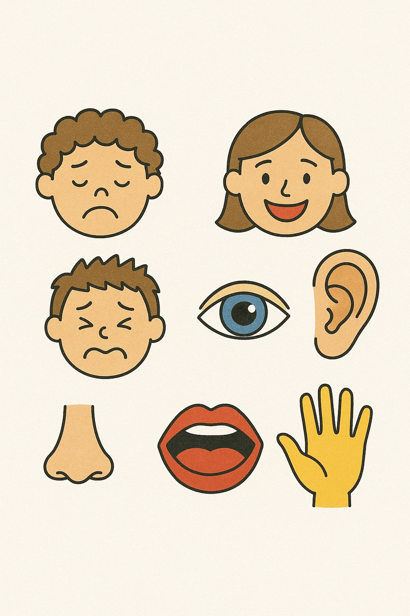

Name: _____________________________________

Date: ______________________________________

Lesson 6 Vocabulary

1. Senses
2. Feelings
3. Temperature
4. Glad
5. Tired
6. Smile
7. Frown
8. Embarrassed
9. Hear
10. Taste
11. Sight
12. Smell

Story - Senses and Feelings

Our faces show our feelings.
Even if we do not speak, people can see how we feel.
When we are sad, we cry.
Our eyes get red.
Our nose may run.
Our lips go down.
When we are happy, we smile.
Our mouth goes up.
We may laugh.
Our eyes can smile too.
When we are angry, we may speak loudly.
Our eyebrows go down.
Our lips press together.
When we are shy or embarrassed, we look down.
We may giggle or smile because we feel nervous.
We feel many things.
At night, we feel tired.
At lunch, we feel hungry.
If we fall, we feel hurt.
The sun feels hot.
Ice feels cold.
We can feel hugs, pinches, or soft things.
We can also feel happy, excited, or sad.
Our eyes help us see.
Some people wear glasses.
Our nose helps us smell.
We can smell cookies or flowers.
We can also smell bad things like a skunk!
Our mouth helps us talk, eat, and drink.
Our teeth and tongue are in our mouth.
Our lips are on the outside.
Our ears help us hear.
We can hear loud or quiet sounds.
Some people wear hearing aids.
Our skin helps us feel.
We can feel hot, cold, soft, or rough.

Comprehension Questions Story – Senses and Feelings

- What do our faces show? Answer: ______
a) Our names
b) Our feelings
c) Our food
- What do we do when we are sad? Answer: ______
a) Smile
b) Laugh
c) Cry
- What do we use to smell with? Answer: ______
a) Our mouth
b) Our ears
c) Our nose
- What do we use to hear? Answer: ______
a) Our skin
b) Our ears
c) Our lips
- Which of these is a feeling? Answer: ______
a) Table
b) Hungry
c) Shoe

Story: Feelings and Emotions

Our faces can show our emotions even if we try not to.
When we are sad, we cry, our eyes water, and we can get a runny nose. Our eyes might be red from crying. Our eyebrows may be wrinkled, and the edges of our lips may turn down.
When we are happy, our mouth smiles by pointing the tips up. We may laugh and show our teeth. Even our eyes can smile.

If we are angry, our eyebrows are pushed down and our eyes close a little bit. We may use a loud voice, or our lips might be squeezed together tightly.

When we are embarrassed, we may not look directly at anyone, but instead look at the floor. We may giggle or smile after a small embarrassment, but that’s because we’re nervous. We’re not laughing at the other person.

There are so many other things we feel. At night, we feel tired. At noon, we feel hungry. If we fell off our bikes, we might feel sore or hurt. The sun feels hot. The ice feels cold. We can feel things physically, like a hug or a pinch. We can feel things emotionally, like sadness or excitement.

Our eyes see what’s around us. Some people wear glasses to help them see. We see our families, our friends, buildings, trees, and everything else when we open our eyes.

Our noses don’t move much when we change our facial expression, unless we smell something terrible like a skunk! But we smell many wonderful things too, like fresh baking, flowers, and new babies.

Our mouths help us speak, but we also use them to eat and drink. Our teeth and tongues are inside our mouth, while our lips are just on the outside of the mouth. The spaces on either side of the mouth are our cheeks.

Our ears hear sounds, but don’t move. We can hear loud things like trains and explosions. We hear quiet things like whispers and kitten mews. We can damage our hearing if we listen to loud music too often. Some people wear hearing aids to help them hear better.

One last thing I need to mention. Our skin can feel things too. These are physical sensations. We can feel hot and cold, smooth and rough, soft and hard, and so much more.

Comprehension Questions – Story - Feelings and Emotions

1. Name two things that can happen to us when we are sad.

Click or tap here to enter text.

2. Name one more thing that we feel emotionally that is not listed in the story.

Click or tap here to enter text.

3. Name one more thing that we can feel physically that is not in the story.

Click or tap here to enter text.

4. List the five senses and what part of the body we use for each. You don’t have to use full sentences. A chart will do.

Click or tap here to enter text.

Story - Hannah’s Emotional Day

Hannah is a teenage girl. She goes to high school.
One day, Hannah ripped her pants at school.
She felt very embarrassed and a little angry.
She had just bought the pants last week.
Hannah tied her sweater around her waist.
Her friend Marta said she could not see the rip.
But Hannah was too scared to take off her sweater.
At lunch, her friend Matthew gave her some gym shorts.
“You can give them back later,” he said.
Hannah smiled. She felt better and wore the shorts.
The sun was shining, and she felt more comfortable.
After school, Hannah went back to the store.
She told the store worker that her pants had ripped.
The worker said, “We can’t give your money back. You wore the pants.”
Hannah showed her receipt.
She said, “I only wore them once. I just bought them last week.”
The worker was calm.
She said, “We can’t give money back, but we can give you store credit.”
Hannah smiled. She was happy.
She loved to shop—especially when she didn’t have to pay.
She looked around the store.
After 20 minutes, she saw a green dress.
Hannah liked it a lot. She wanted to wear it to a school dance next week.
The store worker put the dress in a bag.
Hannah went home. It was after 5:00 p.m.
She was very tired and very hungry.
At home, she showed her mom the dress.
She ate supper, brushed her teeth, and went to bed.
She was tired from her busy, emotional day.

Comprehension Questions Story – Hannah’s Emotional Day

1. What happened to Hannah at school? Answer: ___________
a) She lost her books
b) She ripped her pants
c) She missed the bus

2. How did Hannah feel after Matthew gave her shorts? Answer: ___________
a) Sad
b) Angry
c) Better

3. Why didn’t the store give Hannah her money back? Answer: ___________
a) She lost the pants
b) She wore the pants
c) She had no receipt

4. What did Hannah choose to buy at the store? Answer: ___________
a) A coat
b) A dress
c) More pants

5. Why was Hannah tired at the end of the day? Answer: ___________
a) She danced all night
b) She had a big test
c) She had many feelings

Label the Face

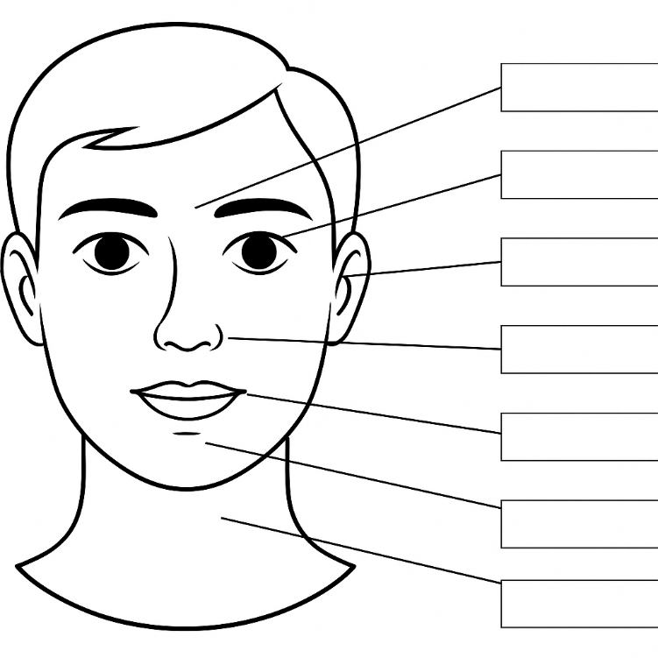

Brow
Chin
Ear
Eye
Neck
Nose
Mouth
Click or tap here to enter text.

Click or tap here to enter text.

Click or tap here to enter text.

Click or tap here to enter text.

Click or tap here to enter text.

Click or tap here to enter text.

Click or tap here to enter text.

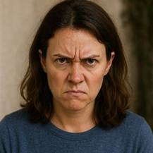 |  | 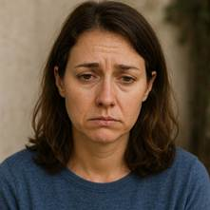
 |  | 
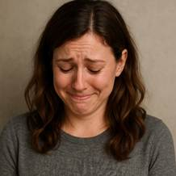 | 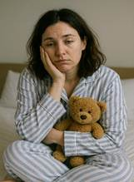 | 

SAD | HAPPY | ANGRY
SCARED | HOT | COLD
CONFUSED | TIRED | EMBARRASSED

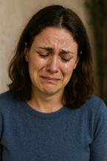 |  | 
 |  | 

LAUGHING | SMILING | CRYING
EXCITED | UNWELL | BORED

Wordsearch Directions:
- Click on the <Draw> tab
- Choose the yellow highlighter
- Find all 16 words and highlight them

