Comprehension Questions Story – Senses and Feelings

- What do our faces show?
a) Our names
b) Our feelings
c) Our food
- What do we do when we are sad?
a) Smile
b) Laugh
c) Cry
- What do we use to smell with?
a) Our mouth
b) Our ears
c) Our nose
- What do we use to hear?
a) Our skin
b) Our ears
c) Our lips
- Which of these is a feeling?
a) Table
b) Hungry
c) Shoe

- Label the following face:

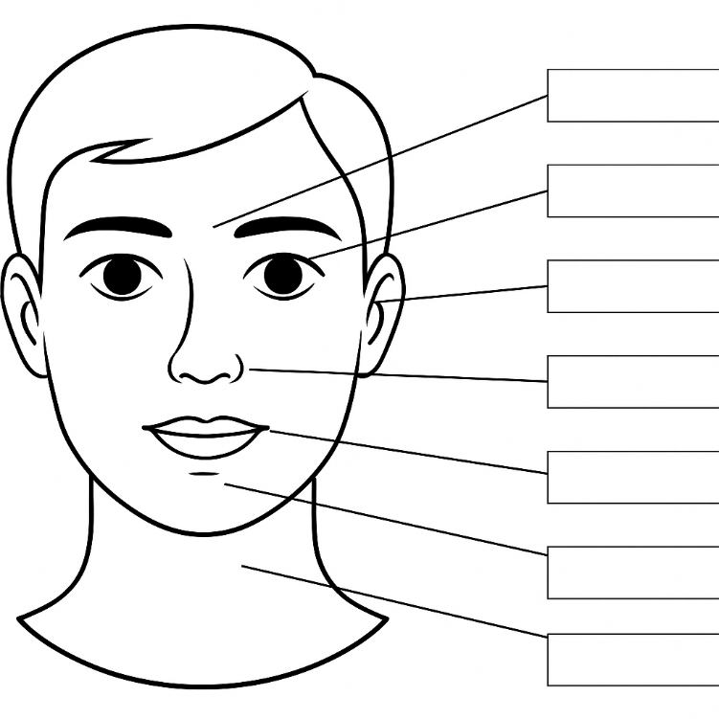

Brow

Eye

Ear

Nose

Mouth

Chin

Neck

Comprehension Questions – Story - Feelings and Emotions

1. Name two things that can happen to us when we are sad.
Cry, nose runs, eyes water, wrinkled eyebrows, lips turn down.

2. Name one more thing that we feel emotionally that is not listed in the story.
Scared, anxious, confused, irritated, etc…

3. Name one more thing that we can feel physically that is not in the story.
Smooth, slippery, rough, soft, etc….tired, hungry, achy…

4. List the five senses and what part of the body we use for each. You don’t have to use full sentences. A chart will do.

Sight - eyes
Hearing - ears
Tasting - tongue/mouth
Smelling - nose
Touch - skin

Comprehension Questions Story – Hannah’s Emotional Day
Answers

1. What happened to Hannah at school?
a) She lost her books
b) She ripped her pants
c) She missed the bus

2. How did Hannah feel after Matthew gave her shorts?
a) Sad
b) Angry
c) Better

3. Why didn’t the store give Hannah her money back?
a) She lost the pants
b) She wore the pants
c) She had no receipt

4. What did Hannah choose to buy at the store?
a) A coat
b) A dress
c) More pants

5. Why was Hannah tired at the end of the day?
a) She danced all night
b) She had a big test
c) She had many feelings

