Functional English

Lesson 5

Homework Assignment

Name:
Date:

Homework Instructions

Please complete Questions 1–10 before next week’s class.

How to Complete the Homework
- Read each question carefully
- Type your answers directly into this document where it says “Click or tap here to enter text.”
- Answer all comprehension questions and writing tasks
- Try your best. Use full sentences where possible, especially for the writing tasks
- You may use a calculator, dictionary or translator if needed

How to Submit Your Homework
- Save the completed document
- Email the document to your instructor before next week’s class
- Make sure your name is on the document or in the email subject line

If you have questions or need help, please contact your instructor.
Do your best—we will review the work together in class!

Question 1: Independent Assignment

Draw a map of a small town. Use at least 10 items from this list in your drawing. Bring it back with you next class.
Vocabulary List
House
Store
Church
Parking lot
Pharmacy
Lake
Stop sign
Road
Sidewalk
River
Speed limit sign
Train tracks
Corner
Yield sign
Intersection
Post Office
Bank
Hill
Pharmacy
Beauty salon

Question 2: Math Practice – Comparing Prices

Comparing Prices at Two Stores
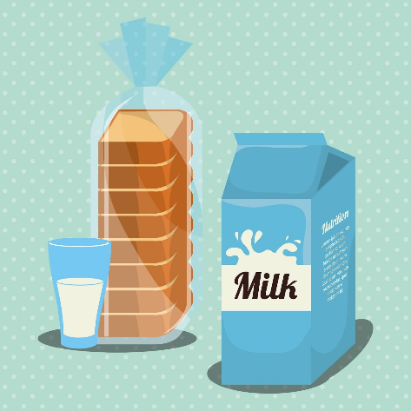
Scenario:
You need a loaf of bread and milk.
http://www.freepik.com
Designed by studiogstock

Store A | Price | Store B | Price
Bread | $2.50 | Bread | $2.80
Milk (1L) | $3.20 | Milk (1L) | $3.00

Questions:
- Where is bread cheaper?

- Where is milk cheaper?

- What is the total cost of buying bread and milk at Store A?

- What is the total cost of buying bread and milk at Store B?

- Which store is cheaper if you buy both items?

- You give the cashier $20 at Store A to purchase bread and milk. How much change should you get?

- How would you give the correct change using bills and coins?

Question 3: Math Practice- Making Change
How many bills and coins are needed to show the correct change.

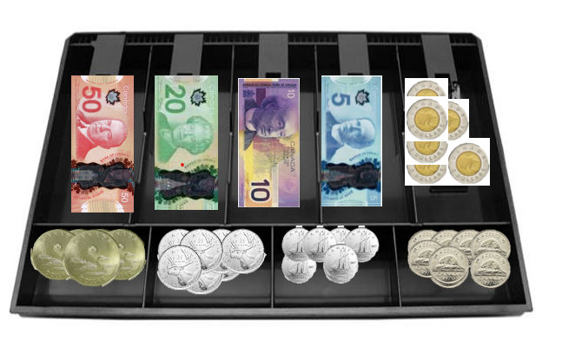
Using the money available in the cash drawer and make the following amounts:
1.  $5.25 | 2.  $17.50
3.  $15.40 | 4.  $16.10
5.  $52.30 | 6.  $39.55

Question 4: Public Services
Read the story Public Services and answer the Comprehension Questions and complete the Writing Task.

Public Services in the Community
People in Northeastern Ontario use many public services.
A library is a place to read books.
A post office is where you send letters.
A fire station helps people in emergencies.
A hospital helps people who are sick.

Comprehension Questions
- Name one public service in your town.

- What do you do at the library?

- Who helps in an emergency?

- Where do sick people go?

Writing Prompt
Write 1–2 sentences: Which public service do you use the most? Why?

Question 5: Public Services in the Community
Read the story Public Services in the Community (It is a little harder than Public Services) and answer the Comprehension Questions.

Public Services in the Community

Northeastern Ontario towns have many public services that help people. Libraries offer books, computers, and reading programs. Post offices let people send letters and packages. Fire stations protect the community and respond to emergencies. Hospitals and clinics provide care for sick or injured people.
Some towns also have community centres where people can take classes, exercise, or meet friends. Public services are important for everyone.

Comprehension Questions
- Name three public services in Northeastern Ontario.

- What can people do at a community centre?

- How does a fire station help the community?

- Why are public services important?

- Name one service you have used.

Writing Prompt
Write 3–4 sentences: Describe a public service you use. What do you do there, and why is it helpful?

Question 6: Our Community’s Public Services
Read the story Our Community’s Public Services (It is a little harder than Public Services in the Community) and answer the Comprehension Questions.

Our Community’s Public Services
Public services are essential in Northeastern Ontario towns and cities. Libraries provide access to books, computers, educational programs, and quiet study spaces. Post offices handle mail, packages, and other government services. Fire stations and police departments maintain safety, responding to emergencies and protecting residents. Hospitals, clinics, and long-term care homes offer medical care for people of all ages.
Community centres provide programs for recreation, education, and social events. These services help people stay healthy, safe, and connected. Access to public services is important for quality of life and supports the community’s economy.

Comprehension Questions
- List four public services mentioned in the passage.

- How do libraries help the community besides giving access to books?

- What roles do fire stations and police departments play?

- Why are community centres important for towns?

- Give one example of a time you might need an emergency service.

Writing Prompt
Write a paragraph about a public service in your town. Explain what it does, who uses it, and why it is important for the community.

Question 7: Healthcare Services
Read the story Healthcare Services and answer the Comprehension Questions and Writing Prompt.

Health Care Services

People in Northeastern Ontario go to hospitals and clinics when they are sick.
Doctors and nurses help people feel better.
Pharmacies sell medicine.
Some people go for check-ups even if they are not sick.

Comprehension Questions
- Where do people go when they are sick?

- Who helps people feel better?

- What do pharmacies sell?

- Why do some people go to the doctor when they are not sick?

Writing Prompt
Write 1–2 sentences: Have you ever visited a doctor or clinic? What happened?

Question 8: Healthcare Services in Northeastern Ontario
Read the story Healthcare Services in Northeastern Ontario (It is a little harder than Health Care Services
and answer the Comprehension Questions.

Healthcare Services in Northeastern Ontario

Healthcare in Northeastern Ontario includes hospitals, clinics, and pharmacies. Doctors and nurses provide care when people are sick or injured. Most hospitals have an emergency department for those who are injured.
Pharmacies give prescription medicine and advice about health. Some clinics offer regular check-ups and vaccinations to keep people healthy. Accessing healthcare is important to prevent illness and stay safe.

Comprehension Questions
- Name three healthcare services in Northeastern Ontario.

- Who provides care in hospitals and clinics?

- What do pharmacies give people?

- Why are regular check-ups important?

- Give one reason why healthcare is important.

Writing Prompt
Write 3–4 sentences: Describe a time you or someone you know went to a clinic or hospital. What was the reason, and how did the staff help?

Question 9: Healthcare for Residents of Northern Ontario
Read the story Healthcare for Residents of Northern Ontario (It is a little harder than Healthcare Services in Northeastern Ontario) and answer the Comprehension Questions.

Healthcare for Residents of Northern Ontario

Residents of Northeastern Ontario rely on a variety of healthcare services, including hospitals, community clinics, and pharmacies. Doctors, nurses, and other healthcare professionals provide treatment for illnesses and injuries, as well as preventive care such as check-ups, screenings, and vaccinations.
Pharmacies dispense prescription and over-the-counter medications and provide guidance on proper use. Access to healthcare ensures that individuals remain healthy and that communities are safe. Understanding how to find and use healthcare services is an important life skill.

Comprehension Questions
- List three types of healthcare services mentioned in the passage.

- What preventive care does doctors provide?

- How do pharmacies help people besides giving medicine?

- What is the difference between treatment and preventive care?

- Why is it important to know how to use healthcare services?

Writing Prompt
Write a paragraph explaining how you would find healthcare services if you were sick or needed a check-up. Include which places you would go to and why.

Question 10: Library Card Application
Task: Fill out the library form application using your own information





