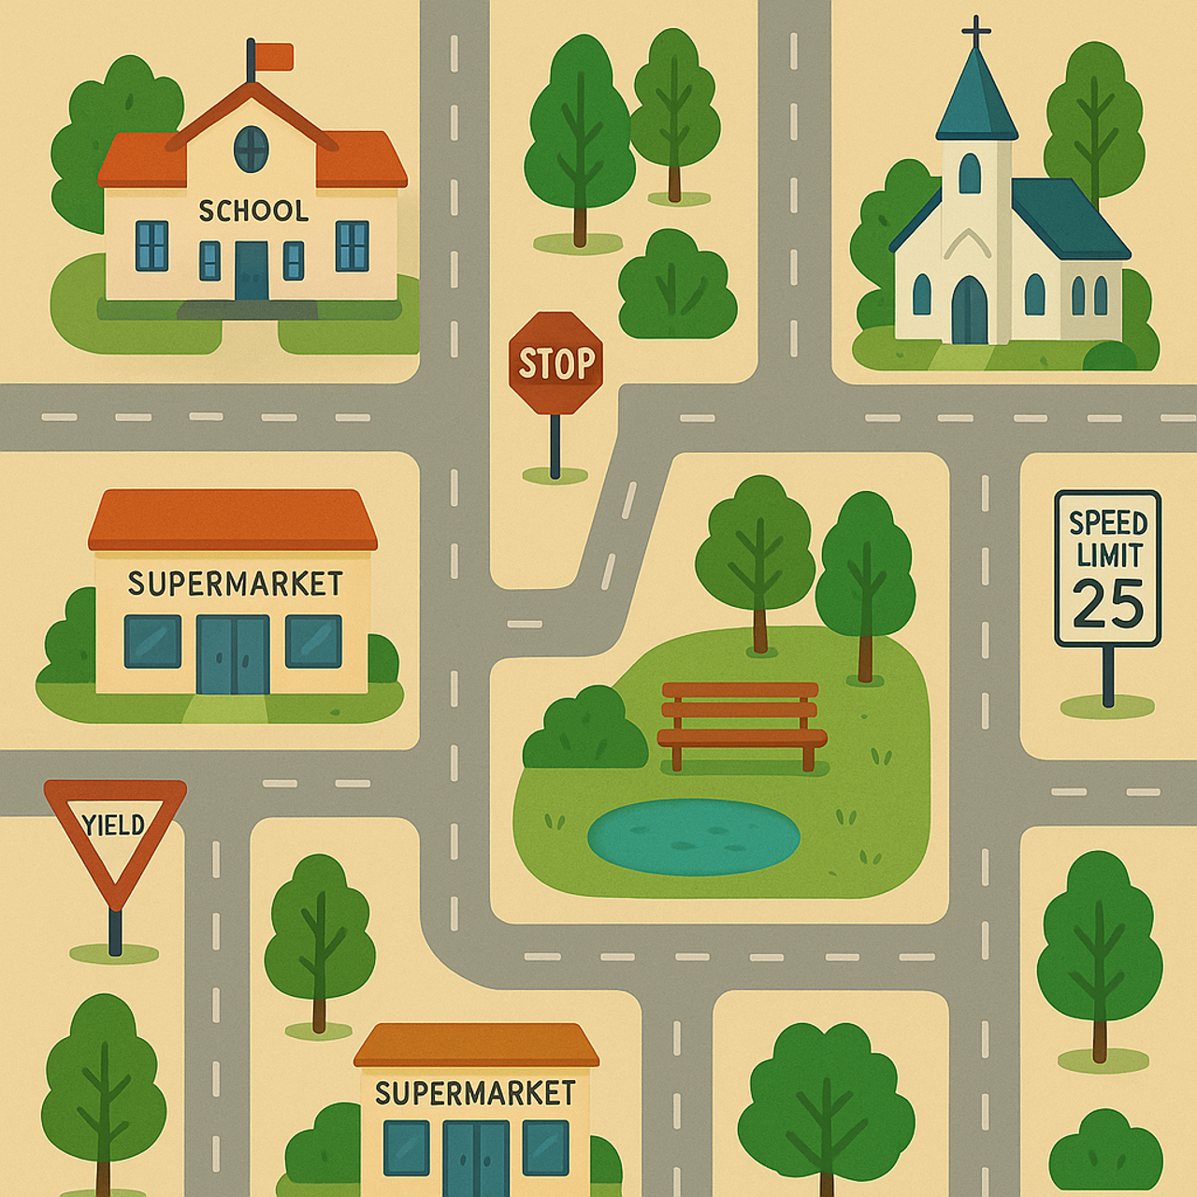
Lesson 5: Directions and Civic Structures

Name: _____________________________________

Date: ______________________________________

Lesson 5 Vocabulary

- Corner
- Sidewalk
- Asphalt
- Neighbourhood
- Parking lot
- School
- Church
- Map
- Lake
- River
- Train tracks
- Avenue

Story 1: Robert Goes Camping

Robert went camping. He packed a tent, a pillow, blankets, some food, and clothes.
He got in his car and drove out of town on the highway.
Soon, he saw the sign for the campground ahead on the right.
He slowed down and turned right. The road was bumpy.
Up ahead, there was a bridge. The bridge looked very old.
Robert was afraid to go over the bridge, but he did it.
He looked behind him. The bridge did not fall down. He was happy.
The road had a big curve to the left. Robert slowed down.
In the distance, there was a big hill, but the road went around and behind the hill.
Robert finally arrived in front of the campground. He paid for a spot at the office and drove to the back of the campground. He took his tent out of the back of the car. He set up his tent and parked his car beside his tent. He left the food in the car so animals wouldn’t take it.
When it got dark outside, he went inside his tent and got into his blankets.
Suddenly, his pillow started to move up and down! Robert jumped up quickly. He looked, but there was nothing under his pillow. He went outside and lifted the corner of his tent. Bending over, he looked underneath the tent. Out of the darkness jumped the biggest frog he had ever seen! Robert was so surprised he fell down on the ground and started to laugh. He didn’t need to be afraid.

Comprehension Questions – Story 1 – Robert Goes Camping

1. Name two things Robert took with him when he went camping.

Click or tap here to enter text.

2. Where was the sign for the campground? Answer: _____________
a) Ahead on the left.
b) Ahead on the right.
c) Behind on the right.

3. Where did Robert park his car? Answer: _____________
a) At the front of the campground.
b) Beside his tent.
c) Behind his tent.

4. How did Robert keep the food safe from animals? Answer: _____________
a) He left it under the tent.
b) He put it beside the car.
c) He put it in the car.

Story 2: Fun at the Campground
Robert woke up from his first night at the campground. He wanted to have some fun.
He walked towards the front of the campground, where the office was. Something landed on his head. He reached his left hand above his head to feel what was there.
It was a big butterfly. It flew off his head.
As he walked forward, he felt a breeze coming from the north. It was a cold breeze.
It’s too soon for winter!
He was happy that he remembered to bring a sweater. He pulled it over his head.
When he arrived at the office, he saw fishing rods and hooks to borrow.
Robert took one rod and two hooks. He headed towards the lake.
When he got there, he noticed he had lost one hook. He looked behind him but didn’t see it. He moved his right foot. There it was under his foot.
Robert fished for a few hours. The sun was up high in the sky. Robert took off his sweater.
He was very hot now that the breeze had stopped. Robert looked out at the beautiful sparkling water. He got up and took off his shirt, socks and shoes. He walked close to the water and dipped his toe in. It felt cool. What do you think Robert decided to do? He ran into the water, splashing and laughing all the way like he did when he was a little boy. What a great day!

Comprehension Questions – Story 2 - Fun at the Campground

1. What landed on Robert’s head? Answer: _____________
a) a butterfly
b) a frog
c) a bumblebee

2. What direction did the breeze come from? Answer: _____________
a) East
b) South
c) North

3. What did Robert take from the campground office? Answer: _____________
a) one hook and two rods
b) two hooks and one rod
c) a sweater

4. Where did Robert dip his toe? Answer: _____________
a) in the breeze
b) over the water
c) in the water

5. Do you think Robert had a good day? Answer: _____________
a) yes, because he was crying
b) yes, because he was laughing
c) no, because he was crying

Direction and Position Opposites and Examples

Word | Opposite | Example
On | Off | The lights are on. Turn off the lights, please.
In | Out | Put the ball in. Take the ball out.
Up | Down | The sun is up. The sun went down.
Left | Right | I use my right hand. She uses her left hand.
Over, On | Under | The ceiling is over my head. The hat is on my head. The floor is under my feet.
Inside | Outside | We must be quiet inside the school. We can make noise outside the school.
Open | Closed | The store is open. The curtains are closed.
Take (from) | Put (back), give | Take a pen from the box. Put the pen back in the box. Please give me your address.
Front | Back, behind | The door is at the front of the school. The garbage goes to the back of the school. I hold the flower in front of myself. I hold the flower behind my back.
Ahead | Behind | She is ahead of me in the race. He is behind me.
Near, Close | Far, away from | My shoes are near (close to) the door. My sister lives far from me (far away).
Here | There | Please come here. Put the cake there.
Lift | Lower | Lift your arms. Lower your arms.
Pick up | Set down | Can you pick up the baby? You can set the mail down on the table.
Towards  Forwards | Away (from)  Backwards | They are walking towards the school. He ran away from home.

Don’t forget words like beside, around, across, and through. They don’t have opposites, but they’re still positional words.

