Functional English

Lesson 4

Homework Assignment

Name:
Date:

Homework Instructions

Please complete Questions 1–12 before next week’s class.

How to Complete the Homework
- Read each question carefully
- Type your answers directly into this document where it says “Click or tap here to enter text.”
- Answer all comprehension questions and writing tasks
- Try your best. Use full sentences where possible, especially for the writing tasks
- You may use a calculator, dictionary or translator if needed

How to Submit Your Homework
- Save the completed document
- Email the document to your instructor before next week’s class
- Make sure your name is on the document or in the email subject line

If you have questions or need help, please contact your instructor.
Do your best—we will review the work together in class!

Question 1: Independent Assignment

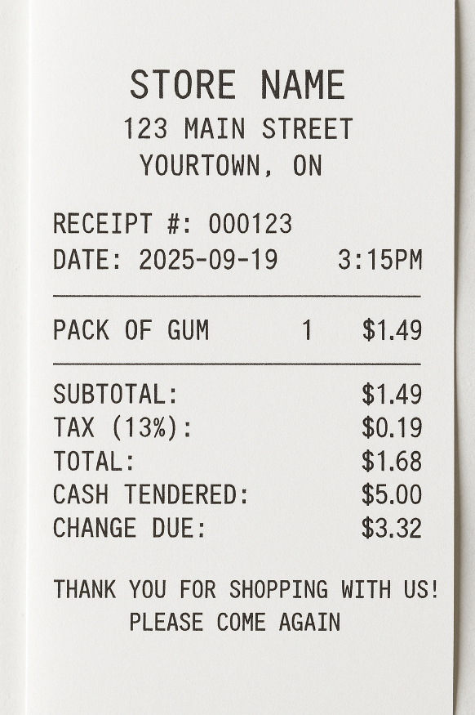
Before next class or session, go to a store and purchase a small inexpensive object, like a pack of gum or a bottle of water. Be sure to pay for it with cash if you can and keep your receipt. On a piece of lined paper, tape your receipt on it and write down how much money you started with, what you bought, how much it cost, and how much change did you get back. Here is an example of a receipt and the list of charges.

Question 2: Math Practice - Grocery Shopping

Scenario: A customer goes to the grocery store to buy fruit. The prices for the fruit are listed. Use these prices to answer the questions below.
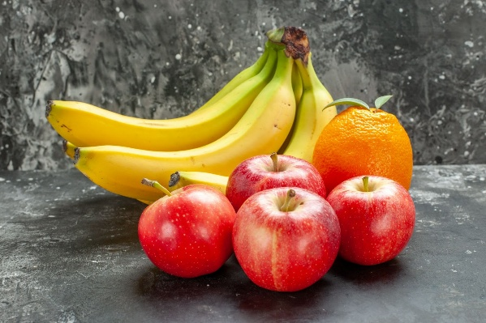
Item | Price per kg
Apples | $3.50
Bananas | $2.80
Oranges | $4.00
http://www.freepik.com
Designed by kamranaydinov
Questions:

- How much would 2 kg of apples cost?

- How much would 1.5 kg of bananas cost?

- Which fruit is the cheapest per kg?
- If they buy 1 kg of apples and 1 kg of oranges, what is the total cost?

4.b) They give the cashier $20 for the apples and oranges. How much change should they get?

4.c) How could the cashier, give the change using bills and coins? (e.g., $10, $5, $1, quarters, dimes, nickels).

Question 3: Math Practice - Making Change
How many bills and coins are needed to show the correct change.

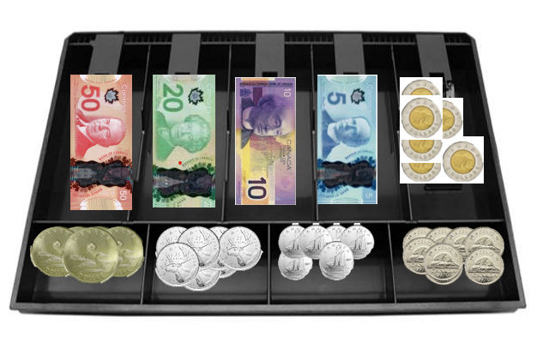
Using the money available in the cash drawer and make the following amounts:
1.  $35.20  Example:  One - $20, Three - $5, Two - $0.10 | 2.  $27.65
3.  $19.85 | 4.  $14.80
5.  $52.10 | 6.  $46.35

Question 4: Math Practice – Flyer Calculations
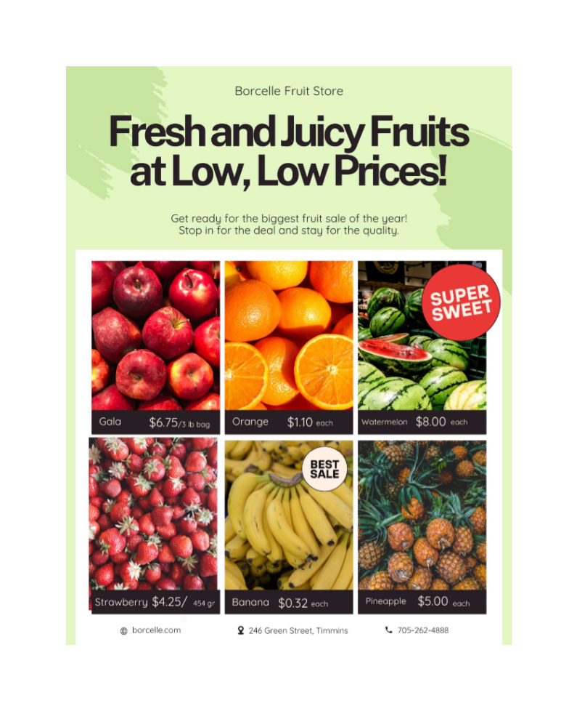

Question 5: Math Practice – Flyer Calculations (Continued)

Using the flyer provided, answer the following questions.

1. Which fruit is marked as the “Best Sale”?

2. How much does one banana and one orange cost at Borcelle’s Fruit Store?

3. A customer buys two oranges. How much does it cost?

3b. If the customer pays with a $20 bill, calculate how much change should they get?

4.. What is the total cost of buying one watermelon and one pineapple?

4b. If a customer pays with a $50 bill, how much change should the cashier provide?

4c. What combination of bills and coins could be used to make the change?

4d. What is another way that the correct change could be made?

Question 6: Math Practice – Flyer Calculations (Continued)
Using the flyer provided, answer the following questions.

5. If there are 3 apples in a pound, how many apples are in a 3 lb bag?

5b. How much does one apple cost?

6. Which fruit costs the most on the flyer?

6b. Give one reason why this fruit costs more?

7. A customer would like to take the exact amount of money to the store to buy one of each of the fruits in the flyer. How much money would they take?

7b. List one combination of bills and coins that are needed to make that amount of money?

8. What is the store’s phone number if you want to call and ask about prices?

9. Where is Borcelle’s Fruit Store located?

10. Why is Borcelle’s having the Fruit Sale?

Question 7: Shopping for Groceries
Read the story Shopping for Groceries and answer the Comprehension Questions and complete the Writing Task.

Shopping for Groceries
People in Northeastern Ontario buy food at stores.
Stores sell fruits, vegetables, meat, and bread.
Some people go to big stores. Some go to small stores.
Farmers’ markets sell fresh food. You can buy vegetables, fruits, eggs, and honey.
People use money to pay for food.

Comprehension Questions
- Where do people buy food?

- Name two things you can buy at a store.

- What can you buy at a farmers’ market?

- What do people use to pay for food?

Writing Prompt
Write 1–2 sentences: What food do you like to buy at the grocery store?

Question 8: Shopping for Groceries Locally
Read the story Shopping for Groceries Locally (It is a little harder than Shopping for Groceries) and answer the Comprehension Questions.

Shopping for Groceries Locally
In Northeastern Ontario, people shop for groceries in many ways. Large stores sell fruits, vegetables, bread, meat, and dairy products. Small stores and corner shops sell some of these items too.
Farmers’ markets are popular. They sell fresh vegetables, fruits, eggs, honey, and sometimes homemade baked goods. Buying local food helps farmers and gives people fresh options. People use money or debit cards to pay.

Comprehension Questions
- Name three foods you can buy at a large store.

- What is sold at farmers’ markets besides fruits and vegetables?

- Why is buying local food helpful?

- How do people pay for groceries?

- What is one difference between big stores and small stores?

Writing Prompt
Write 3–4 sentences: Describe your favourite grocery store. What do you buy there, and why do you like it?

Question 9: Shopping for Groceries in Northeastern Ontario
Read the story Shopping for Groceries in Northeastern Ontario (It is a little harder than Shopping for Groceries Locally) and answer the Comprehension Questions.

Shopping for Groceries in Northeastern Ontario
People in Northeastern Ontario have several options for buying groceries. Large supermarkets offer a wide range of products including fruits, vegetables, bread, meat, dairy, and packaged foods. Small local shops and corner stores sell select items and are convenient for quick shopping trips.
Farmers’ markets are an important part of the local food system. They provide fresh vegetables, fruits, eggs, honey, and baked goods directly from local producers. Buying from these markets supports farmers and promotes healthier, seasonal eating.
Payment methods include cash, debit, and credit cards. Many stores now also accept mobile payments. Shopping locally helps the community’s economy while giving residents access to fresh and seasonal foods.

Comprehension Questions
- What kinds of products are sold at supermarkets in Northeastern Ontario?

- Name three items you can buy at a farmers’ market.

- Why is buying from farmers’ markets good for the community?

- What are some ways people can pay for groceries?

- What does “seasonal” food mean, and why is it important?

Question 10: Foods in Northeastern Ontario
Read the story Foods in Northeastern Ontario and answer the Comprehension Questions and Writing Prompt.

Foods in Northeastern Ontario
Northeastern Ontario has many kinds of food.
Farmers grow vegetables like carrots, potatoes, and beans.
People have cows and chickens on farms. They get milk, eggs, and cheese.
Some people catch fish in lakes and rivers.
Local stores sell this food for people to buy.

Comprehension Questions
- Name two vegetables grown in Northeastern Ontario.

- What animals do people have on farms?

- Where do people catch fish?

- Where can people buy local food?

Writing Prompt
Write 1–2 sentences: What is your favourite food from a farm or lake?

Question 11: Foods Grown in Northeastern Ontario
Read the story Foods Grown in Northeastern Ontario (It is a little harder than Foods in Northeastern Ontario) and answer the Comprehension Questions.

Foods Grown in Northeastern Ontario

In Northeastern Ontario, farmers grow many types of vegetables and fruits. Common crops include potatoes, carrots, beans, and apples.
People raise cows, chickens, and other animals for milk, eggs, and meat. Local fishers catch fish in lakes and rivers, which can be sold fresh or frozen.
Many of these foods are sold in local grocery stores, farmers’ markets, or used in restaurants. Eating local food helps the economy and is often very fresh.

Comprehension Questions
- Name three crops grown in Northeastern Ontario.

- What foods do farmers get from cows and chickens?

- How do fishers sell their catch?

- Why is local food often better than food from far away?

- Where can people buy local food?

Writing Prompt
Write 3–4 sentences: Describe one local food you like. Where does it come from, and how do you eat it?

Question 12: Foods Grown and Made in Northeastern Ontario
Read the story Foods Grown and Made in Northeastern Ontario (It is a little harder than Foods Grown in Northeastern Ontario) and answer the Comprehension Questions.
Foods Grown and Made in Northeastern Ontario

Northeastern Ontario produces a variety of foods thanks to its farms, lakes, and forests. Farmers grow vegetables like carrots, potatoes, and beans, as well as fruits such as apples and berries. Livestock, including cows, chickens, and pigs, provide milk, eggs, meat, and cheese.
Fishing is another important activity. People catch fish in rivers and lakes for local markets or for personal use. Many restaurants and stores in towns buy these locally grown and caught foods. Eating locally supports the community, reduces transportation costs, and provides fresh, healthy options.

Comprehension Questions
  - List three vegetables and two fruits grown in Northeastern Ontario.

  - What products come from chickens?

  - How does fishing contribute to local food supply?

  - Why is eating locally grown food beneficial for the community?

  - Where do restaurants and stores get local foods?

Writing Prompt
Write a paragraph describing how you might find foods for recipes that may not be available locally.

