Lesson 4: Shopping

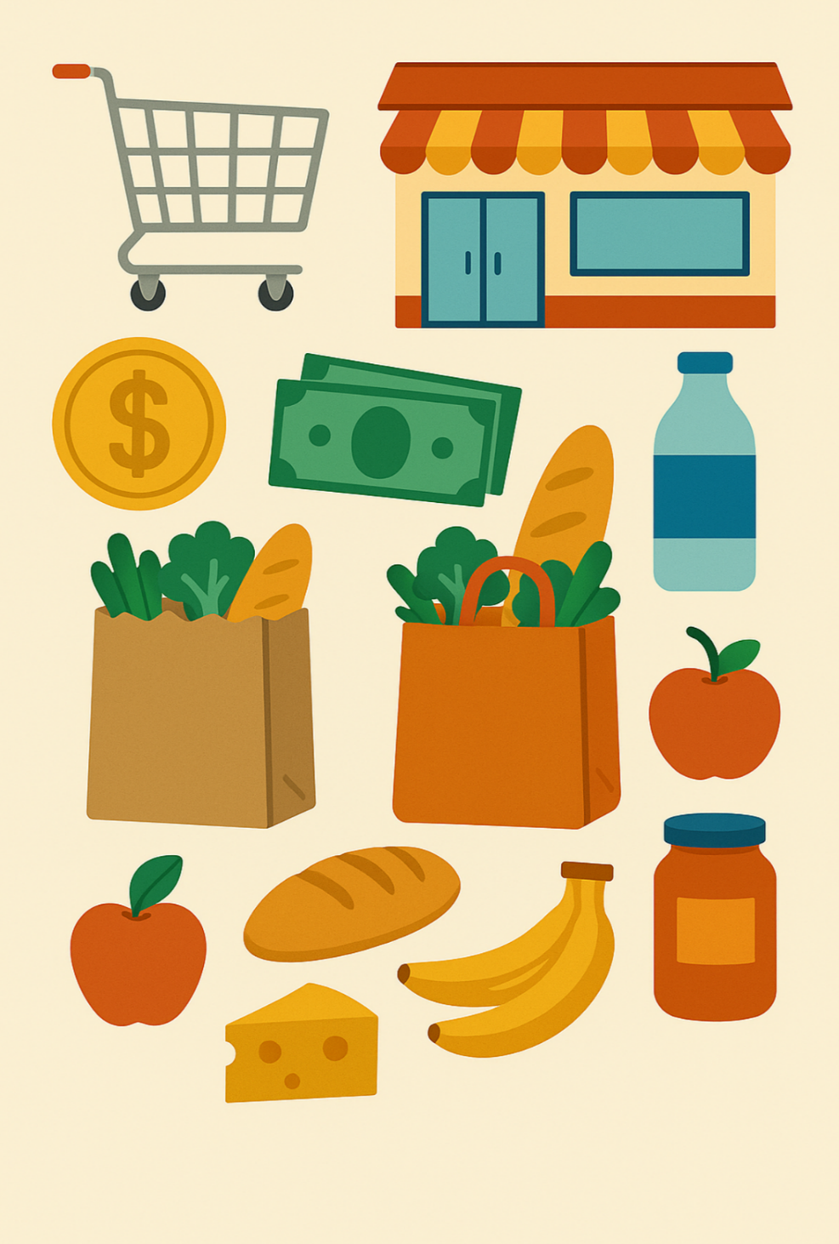

Name: _____________________________________

Date: ______________________________________
Lesson 4 Vocabulary

- Purchase
- Tax
- Discount
- Loonie
- Butcher
- Groceries
- Bank
- Hair Salon
- Exchange
- Pharmacy
- Budget
- Refund

Story 1 - Shopping in My Town
I need to buy groceries.
I go to the grocery store.
I make a budget.
I do not want to spend too much.
I look for a discount.
I use a loonie to buy apples.
I go to the butcher.
I purchase some chicken.
I go to the bank.
I take out money.
I go to the pharmacy.
I need medicine.
I ask for a refund.
The price was wrong.
I go to the hair salon.
I pay tax for my haircut.
I go home.
I check my budget.
I did not spend too much!

Please answer the following questions:

- Where does the person buy apples?

Click or tap here to enter text.

- Where does the person buy chicken?

Click or tap here to enter text.

- Why does the person go to the bank?

Click or tap here to enter text.

- What does the person ask for at the pharmacy?

Click or tap here to enter text.

- Does the person stay on budget?

Click or tap here to enter text.

Story 2 - My Weekend Shopping

On Saturday, I always plan my shopping. I make a budget so I know how much I can spend. I try to look for a discount if I want to save money.
First, I go to the grocery store to buy groceries. I take my list with me so I do not forget anything. I find apples on sale, and I use a loonie to pay for them.
Next, I visit the butcher to purchase some fresh meat. The butcher gives me a small discount because I am a regular customer.
After that, I stop at the bank to take out some cash. I prefer to use cash so I can see how much I spend.
I also go to the pharmacy to get my medicine. One item has the wrong price, so I ask for a refund. The worker is kind and helps me.
Before I go home, I stop at the hair salon for a haircut. I pay the bill, and I also pay the tax.
Sometimes I exchange something if it doesn’t work or fit. This time, I did not need to exchange anything.
At home, I check my budget again. I am happy because I stayed on budget this weekend.
Comprehension Questions:

- Why does the person make a budget?

Click or tap here to enter text.
- Where does the person buy groceries?

Click or tap here to enter text.
- Why does the person ask for a refund?

Click or tap here to enter text.
- What does the person pay tax on?

Click or tap here to enter text.
- Does the person need to exchange anything this time?

Click or tap here to enter text.
- How does the person feel at the end of the weekend?

Click or tap here to enter text.

5. Practice Activities

Using the photocopied flyers on the next pages, you’re going to go shopping for the ingredients needed to make a simple meal. You have $20 to spend.

1. Look through the flyers at what’s on sale this week.

- Now that you know what could be available, decide what you will make.

Click or tap here to enter text.

- Write down your ingredients and their prices from the flyers.

Click or tap here to enter text.

4. Briefly explain what you are making.

Click or tap here to enter text.
