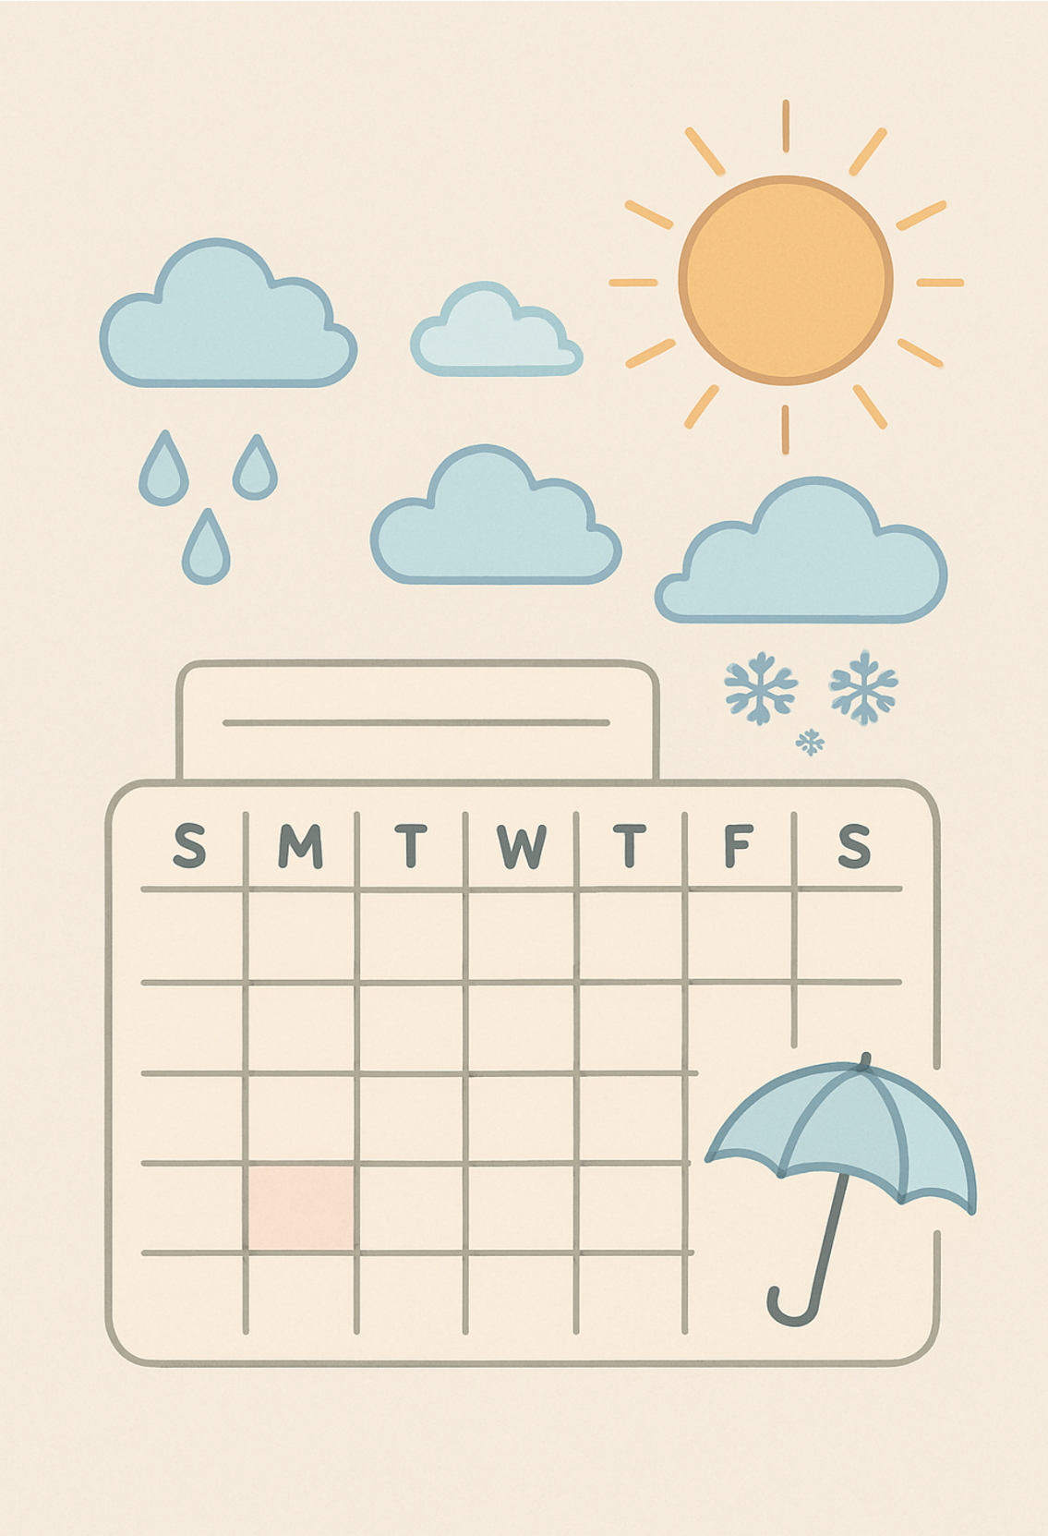
Lesson 3: The Calendar, the Weather, and Time

Name: Click or tap here to enter text.

Date: Click or tap here to enter text.

Lesson 3 Vocabulary

- Calendar
- Weather
- Season
- Blizzard
- Clock
- Thunder
- Month
- Weeks
- Days
- Temperature
- Hour
- Minute

Story 1 - Jill and Jane are Late

It is morning.
Jill and Jane have school today.
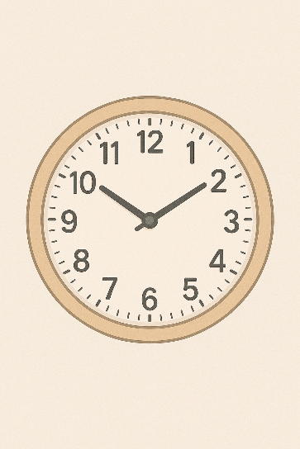
Mother just woke up.
She forgot to set the alarm clock.
She should do it at night so they are not late.
Oh no! They missed the school bus!
The girls will have to walk to school.
How long will it take them to get to school?
It will take them 30 minutes if they walk.
It will take them 15 minutes if they ride their bikes.
Jill and Jane ride their bikes to school.
The girls are very sorry for being late.
They love going to school.
Today, Jane is going to learn about clocks.
She will learn about hours, minutes, and seconds.

Jill is going to learn about the seasons.
She will learn about how the seasons change every year.

Comprehension Questions – Story 1 – Jill and Jane are Late

1. What time of day did the girls wake up? Answer: Click or tap here to enter text.
a) Night
b) Morning
c) Evening

2. Who forgot to set the alarm clock? Answer: Click or tap here to enter text.
a) Father
b) Grandmother
c) Mother

3. How long will it take Jill and Jane to get to school on their bikes? Answer: Click or tap here to enter text.
a) 30 Minutes
b) 15 Seconds
c) 15 Minutes

4. What is Jill going to learn in school today? Answer: Click or tap here to enter text.
a) Money
b) Planets
c) Seasons

5. Jane is learning about clocks. What will she learn about? Answer: Click or tap here to enter text.
a) Hours, minutes, and seconds
b) Minus, months, and dates
c) Hours, animals, and seasons

Story 2 - Telling Time

Ben is Jill’s father.
Ben is teaching Jill how to tell time.
He shows Jill the clock with the numbers from 1 to 12 on its face.
He shows her the long hand and the short hand.
“The long hand shows the minutes.” Ben says.
“The short hand shows the hours.” Jill says.
She learned that in school.
Ben then tells Jill all about time.
One second is very quick.
Sixty seconds make one minute.
And 60 minutes make one hour.
Then, 24 hours mark one whole day.

The clock's hands have to go around twice to make a full day.
There are 5 minutes between each number on the clock.
We can count by 5s. Let’s try!
5…10…15…20…25…30
That’s great!
The minutes on the right side of the clock show time after the hour.
We might say, “It is 20 minutes after 3:00.”
The minutes on the left side of the clock show time before the hour.
We might say, “It is 10 minutes to 3:00.”
A.M. means morning. We say, “Good morning!”
P.M means night. We say, “Good night!”

Comprehension Questions – Story 2 – Telling Time

1. What do the long hand and the short hand show? Answer: Click or tap here to enter text.
a) Weather and Time
b) Minutes and Hours
c) Time and Minutes

2. Fill in the missing words.

Sixty ____________ makes one minute.
And 60 minutes makes one __________.
Then ______ hours mark one whole day.

3. How many minutes are there between each number on the clock? Answer: Click or tap here to enter text.
a) 10
b) 1
c) 5

4. How many minutes between the 2 and the 7 on the clock? Answer: Click or tap here to enter text.
a) 30 minutes
b) 20 minutes
c) 25 minutes

5. Write the time using words. There could be more than one way of saying the time.

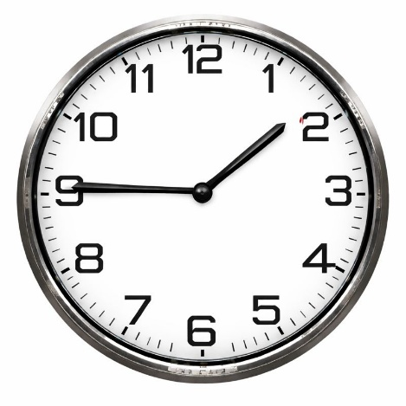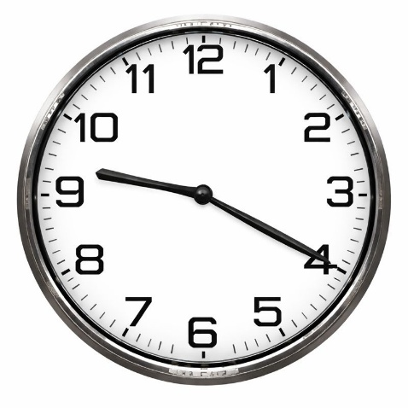
A:___Click or tap here to enter text. B:___Click or tap here to enter text.
Beginning Level 1 Story: The Weather and Time
I look at the calendar.
The calendar shows the days and the months.
I look outside.
The weather is bad today.
It is winter. That is the season now.
There is a blizzard.
The snow is very deep.
The temperature is very cold.
It is -20 degrees.

I see the clock.
The clock tells me the time.
It is 10 o’clock.
It is morning.

I miss summer and thunderstorms.
It will be months before I can wear shorts again.
I look at the calendar again.
There are six months until summer.
There are four weeks in this month.
There are seven days in one week.
There are 24 hours in one day.
There are 60 minutes in one hour.
Today is a good day to stay inside!

Comprehension Questions - Beginning Level 1 Story: The Weather and Time
- What season is it? Click or tap here to enter text.

- What is the weather like? Click or tap here to enter text.

- What time is it? Click or tap here to enter text.

- What is the temperature? Click or tap here to enter text.

- How many days are in a week? Click or tap here to enter text.

Higher Level 1 Story: Weather, Time, and Seasons
I always check my calendar in the morning. The calendar helps me keep track of the days, weeks, and months. It also helps me remember appointments.
Today, I look out the window and see that the weather is very bad. It is winter now, and that is my least favourite season. There is a blizzard outside. The wind is strong, and the snow is blowing everywhere. The temperature is very cold today — it is -20 degrees.
I love thunder! I can hardly wait until it is summer again.
I check the clock. The clock says it is 10 o’clock in the morning. I know there are 60 minutes in every hour and 24 hours in one day.
There are seven days in a week and four weeks in a month. I mark important dates on my calendar so I don’t forget them.
Today, I will stay home where it is warm and safe.

Comprehension Questions - Higher Level 1 Story: Weather, Time, and Seasons
1. Why does the person check the calendar? Click or tap here to enter text.

2. What season is it? Click or tap here to enter text.

3. What is the weather like today? Click or tap here to enter text.

4. How cold is it outside? Click or tap here to enter text.

5. How many minutes are in an hour? Click or tap here to enter text.

6. What will the person do today? Click or tap here to enter text.

Seasons and Weather Worksheet Name: _________

Use the blank chart on the next page, gather your information about seasons. Put the name of each season in each square on the line. Don’t forget that you also need…
- The weather
- Two other facts about the season, such as…
  - The clothes we wear
  - The months that it covers, or
  - The celebrations we have in Canada
  - Activities we can do in each season

When you have finished, be sure to write proper sentences for each season.

Here is an example with more than two facts.

The name of the season is summer.
It happens during the months of June, July, August and September.
It is hot and sunny.
We can go camping.
We celebrate Canada Day in the summer.
There is no school in the summer.
We can wear shorts and bathing suits.

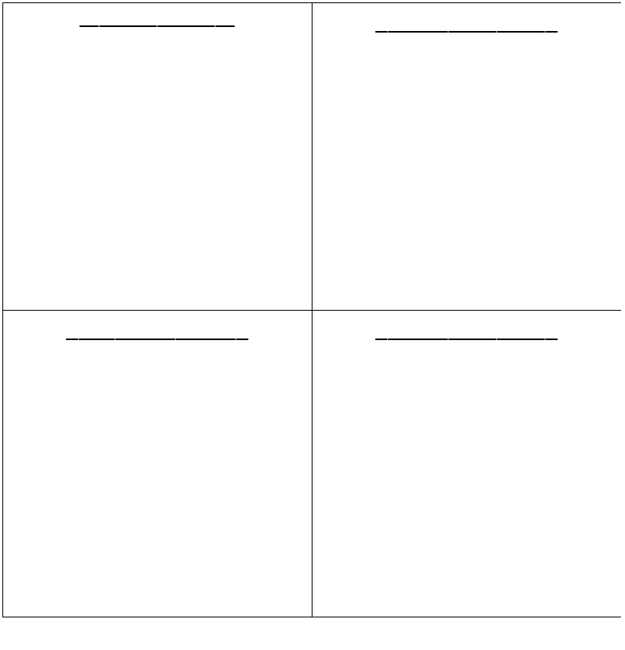
Seasons and Weather Worksheet
Season:
Click or tap here to enter text.
Facts:

Click or tap here to enter text.
Season:
Click or tap here to enter text.
Facts:

Click or tap here to enter text.
Season:
Click or tap here to enter text.
Facts:

Click or tap here to enter text.
Season:
Click or tap here to enter text.
Facts:

Click or tap here to enter text.
Season:

