Comprehension Questions – Story -Jill and Jane are Late
Answers

1. What time of day did the girls wake up?
a) Night
b) Morning
c) Evening

2. Who forgot to set the alarm clock?
a) Father
b) Grandmother
c) Mother

3. How long will it take Jill and Jane to get to school on their bikes?
a) 30 Minutes
b) 15 Seconds
c) 15 Minutes

4. What is Jill going to learn in school today?
a) Money
b) Planets
c) Seasons

5. Jane is learning about clocks. What will she learn about?
a) Hours, minutes, and seconds
b) Minus, months, and dates
c) Hours, animals, and seasons

Comprehension Questions – Story – Telling Time
Answers

1. What do the long hand and the short hand show?
a) Weather and Time
b) Minutes and Hours
c) Time and Minutes

2. Fill in the missing words.

Sixty __minutes__________ makes one minute.
And 60 minutes makes one ____hour______.
And __24____ hours mark one whole day.

3. How many minutes are there between each number on the clock?
a) 10
b) 1
c) 5

4. How many minutes between the two and the seven on the clock?
- 25 minutes
- 20 minutes
- 30 minutes

5. Write the time in words. Answer may vary. 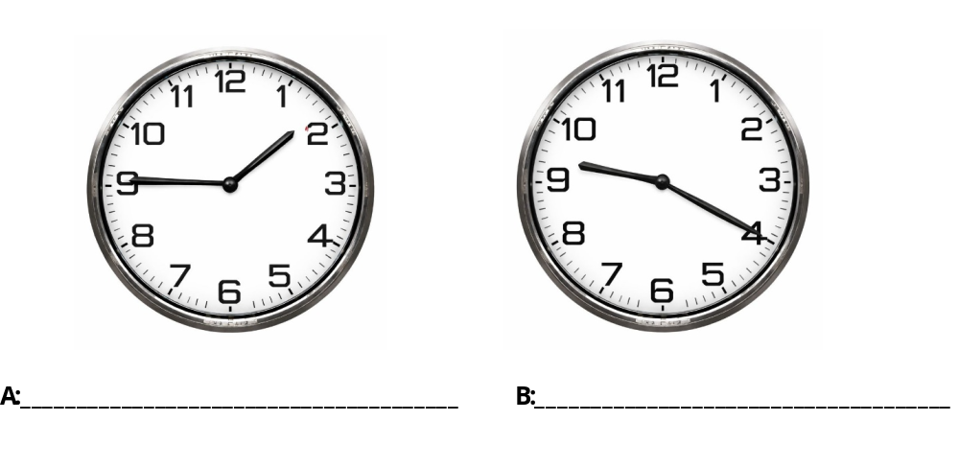
A) One-forty-five, Fifteen minutes to two, Forty-five minutes after one, quarter to two
B) Nine-twenty, Twenty minutes after nine, twenty after nine.

Comprehension Questions: - The Weather and Time
Answers
- What season is it? It is winter
- What is the weather like? The weather is bad, it is winter, there is a blizzard, the snow is deep.
- What time is it? It is 10 o’clock in the morning.
- What is the temperature? It is -20 degrees.
- How many days are in a week? There are seven (7) days in a week.

Comprehension Questions: - Weather, Time, and Seasons
Answers
1. Why does the person check the calendar? Keep track of days, remember appointments
2. What season is it? It is winter.
3. What is the weather like today? The weather is bad, there is a blizzard, the wind is strong, the snow is blowing, and it is very cold.
4. How cold is it outside? It is -20 degrees.
5. How many minutes are in an hour? 60
6. What will the person do today? They will stay home where it is safe and warm.

Seasons and Weather Worksheet – Answers will vary.

