Lesson 2 Personal and Family Information

Hello. My name is...
I am XX years old.
My birthday is DD/MM/YYYY.
I live at 123 Front Street, Apartment 3,
Newtown, Ontario. A1A 1A1.
My phone number is (111) 234-5678.
I'd like you to meet my family.
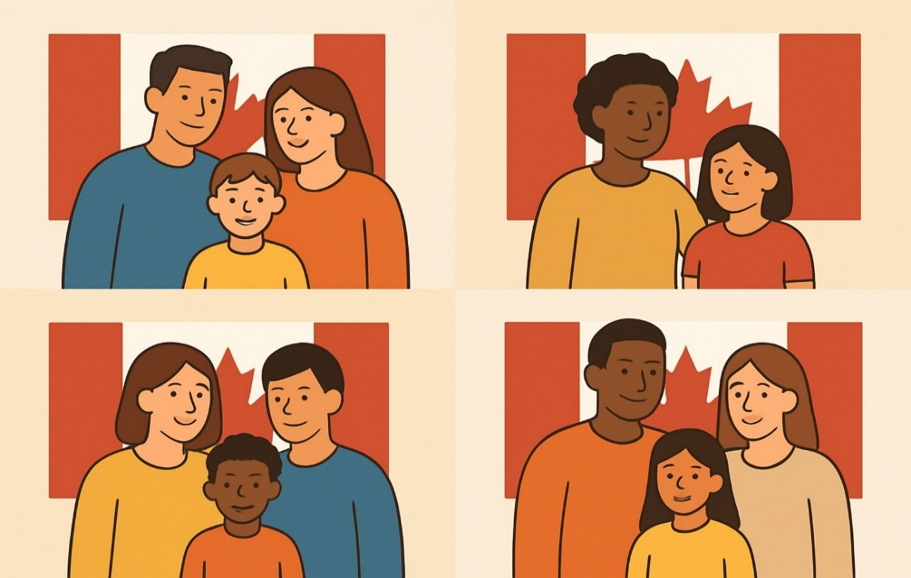

Name: Click or tap here to enter text.

Date: Click or tap to enter a date.

Lesson 2 Vocabulary

- Address
- Birthday
- Mother
- Father
- Sister
- Brother
- Grandmother
- Grandfather
- Parents
- Siblings
- Married
- I have/ I am

Story 1: Meet Jen
My name is Jen.
My birthday is May 14, 1979.
I have black hair.
I am 46 years old.
I am married to Ben.
He is 49 years old.
His birthday is March 9, 1976.
We have two daughters.
Jane was born first.
She is older.
Her sister is Jill.
Jill is younger.
She has red hair.
Her birthday is in the winter.
We have a cat.
His name is Max.
He is a boy cat.
The girls like to play with Max.
Max likes to play with the sisters.
We live in a green house.
Our house is on Martin Street.
My mother will be visiting today.
She is the grandmother to Jill and Jane.
Jill and Jane are happy to see Grandmother.
They have cake for Grandmother.

Comprehension Questions – Story 1
1. How old is Jen? Answer: Click or tap here to enter text.
a) 47
b) 49
c) 46

2. Who is Jen married to? Answer: Click or tap here to enter text.
a) Jill
b) Ben
c) Fred

3. Which daughter is older: Answer: Click or tap here to enter text.
a) Jill
b) Jen
c) Jane

4. What street does Ben live on? Answer: Click or tap here to enter text.
a) Marvin Street
b) Main Street
c) Martin Street

5. What do Jill and Jane have for Grandmother? Answer: Click or tap here to enter text.
a) Cookies
b) Cake
c) Carrots

Story 2 - My Family

My name is Ana.
I am 35 years old.
I am married.
I live at 123 King Street. That is my address.
My birthday is in May. I have a big family.
I have a mother and a father.
My mother is kind.
My father is funny.
My parents are good people.
I have a brother and a sister.
My brother is tall.
My sister is smart.
They are my siblings.
I have a grandmother and a grandfather.
My grandmother is 80 years old.
My grandfather is 85 years old.
I love my grandparents.
I am happy to have my family.
I have a good life.

Comprehension Questions:

- What is Ana’s address? Click or tap here to enter text.
- When is Ana’s birthday? Click or tap here to enter text.
- Is Ana married? Click or tap here to enter text.
- How many siblings does Ana have? Click or tap here to enter text.
- How old is Ana’s grandmother? Click or tap here to enter text.
- Does Ana love her family? Click or tap here to enter text.

Story 3: Jen’s Cat Max Runs Away - Supplementary

Max is my cat.
He has a tag on his collar.
The tag has my phone number.
Max ran away.
Jill will help me find him.
We look on our street.
We cannot find him.
We look in the yard.
We cannot find him.
Where is Max?
The phone is ringing!
“Hello?”, I said.
“Hello,” the lady said,
“I have your cat, Max. What is your address?”
“I live at 123 Martin Street, in Bigtown, Ontario.” I told her.
Max is home now.
Max is a bad kitty.
Jane is happy that Max is back home.
Ben will fix the hole in the door.
Max will not run away again.

Comprehension Questions – Story 3

1. What is Max wearing? Answer: Click or tap here to enter text.
a) Collar and tag
b) collar
c) dress

2. Who will help Jen find Max: Answer: Click or tap here to enter text.
a) Ben
b) Grandmother
c) Jill

3. What did the lady find? Answer: Click or tap here to enter text.

4. What is Jen’s address? Click or tap here to enter text.

5. Who will fix the door: Answer: Click or tap here to enter text.

Story 4 - Ana’s Family – Supplemental

My name is Ana, and I am 35 years old. I live at 123 King Street. That is my address. I am married, and I live with my husband.
My birthday is in May. I usually have a small party with my family on my birthday.
I have a mother and a father. My parents are very kind and helpful. They live in another city, but I talk to them on the phone every week.
I also have one brother and one sister. They are my siblings. My brother is older than me, and my sister is younger. My brother works in construction, and my sister is a teacher. We try to see each other on holidays because we are all busy.
My grandparents are very special to me. My grandmother is 80 years old, and my grandfather is 85. They live in a small house near the lake. I like to visit them in the summer.
I am happy to have a big, loving family. I enjoy spending time with them when I can.

Comprehension Questions:

- Where does Ana live? Click or tap here to enter text.
- Who does Ana live with? Click or tap here to enter text.
- How often does Ana talk to her parents? Click or tap here to enter text.
- What jobs do Ana’s brother and sister have? Click or tap here to enter text.
- Where do Ana’s grandparents live? Click or tap here to enter text.
- Why is Ana happy? Click or tap here to enter text.

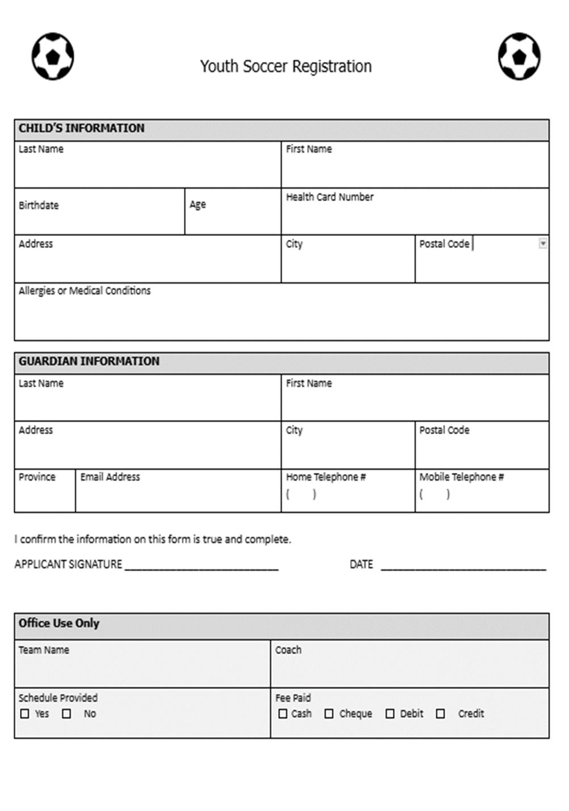

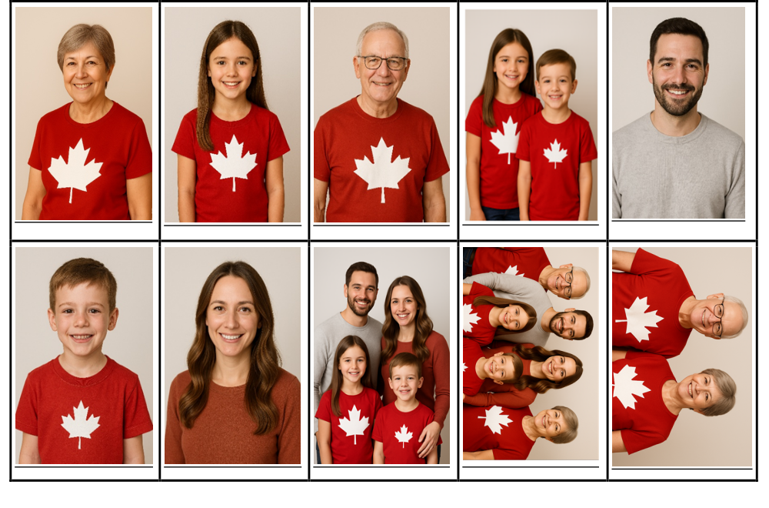

Mother  Wife  Daughter  Sister  Aunt  Woman | Father  Husband  Son  Brother  Uncle  Man | Grandmother  Mother  Wife  Daughter  Sister  Aunt  Woman | Grandfather  Father  Husband  Son  Brother  Uncle  Man | Sister  Daughter  Granddaughter  Grandchild  Cousin  Sibling  Girl
Brother  Son  Grandson  Grandchild  Cousin  Sibling  Boy | Siblings  Brother & Sister  Boy & Girl  Children  Grandchildren | Family  This picture is what we call a nuclear family.  There are many different types of families. | Grandparents  Grandmother & Grandfather  Wife & Husband  Married  Mother & Father | Parents  Husband & Wife  Father & Mother  Man & Woman  Married  Children

Personal Details

Fill in this chart with your personal information. You will need to use this information often. Practice reading these sentences out loud, and then try without looking.

My name is ______________________________________________.

My birthday is ____________________________________________.

I am ______________________________ years old.

My address is __________________________________________________.

My phone number is ______________________________________.

Fill in the Verbs

Mini Lesson: Review these two verbs with the students. Use actions to show the difference between the pronouns. For example, “I have a book.” The instructor holds a book. “You have a book.” The instructor gives a book to someone while saying it at the same time. “She has a book.” Give it to someone else, continue addressing the original student, but point over at the girl who has the book, etc.

To Have

I have I have a cat.

You have You have a book

He has He has a ball.

She has She has a doll.

We have We have a dog.

You (all) have You (all) have pencils.

They have They have books.

To Be

I am I am a teacher.

You are You are a student

He is He is a boy.

She is She is a girl.

We are We are humans.

You (all) are You (all) are in my class.

They are They are late.
Fill in the blanks using one word per line. There will be one word left over in each sentence.

  - I ___________ a person. (am have)

  - She ______________ running. (is has)

  - They ______________ hungry. (have are)

  - We ______________ a turtle. (are have)

  - He ___________ tall. (is has)

  - You _______________ a green bicycle. (are have)

  - She _____________ a little brother. (has is)

  - They ______________ coloured pencils. (are have)

  - I ___________ cold. I _______________ a sweater on. (have am are)

  - We ________ in the class. We __________ to learn more. (is have are)

