Lesson 1 Greetings and Introductions

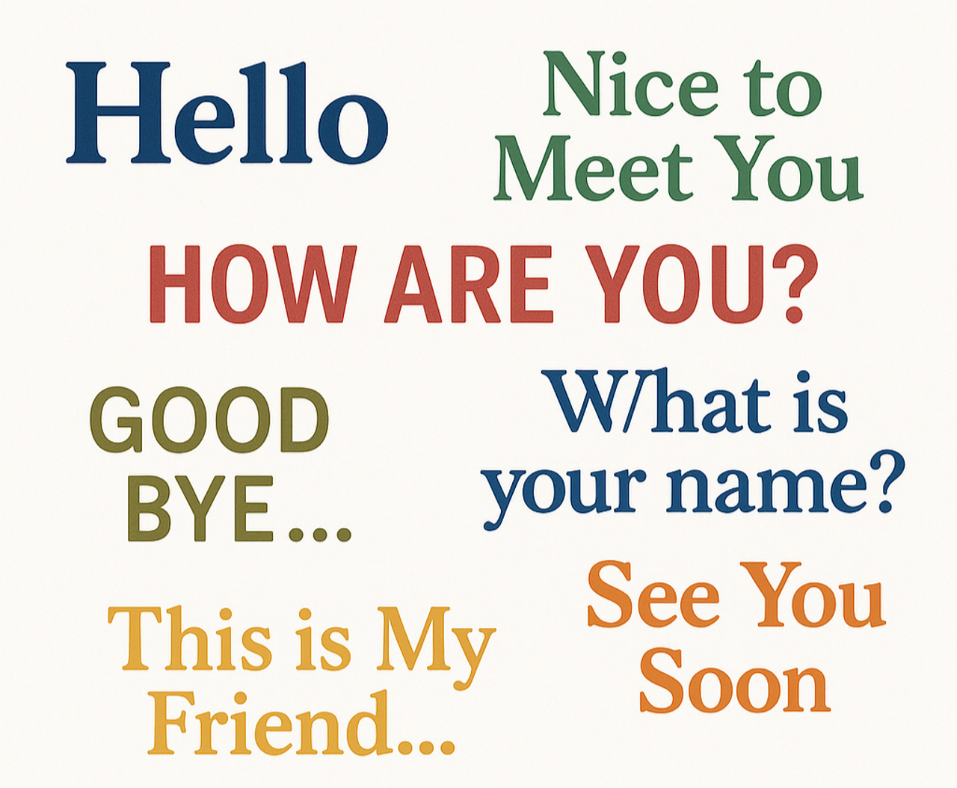

Name: _____________________________________

Date: ______________________________________
Lesson 1 Vocabulary

- Hello
- Goodbye
- Name
- Please
- Thank you
- Excuse me
- How
- What
- Who
- Nice
- Meet
- Speak

Story 1: Hello, My Name Is Ana

Ana is new.
She goes to class.
She sees a man.
She says, “Hello.”
The man says, “Hello. What is your name?”
Ana says, “My name is Ana.”
The man says, “Nice to meet you, Ana.”
Ana smiles. “Nice to meet you, too.”
A woman comes in.
Ana says, “Hello.”
The woman says, “Excuse me, who are you?”
Ana says, “My name is Ana.”
The woman says, “Do you speak English?”
Ana says, “Yes, I speak a little.”
Ana says, “Can we sit together?”
The woman says, “Yes!”
Ana says, “Thank you.”
The woman says, “You are welcome.”
At the end of class, Ana says, “Goodbye!”
Everyone says, “Goodbye, Ana!”

Comprehension Questions – Story 1

1. What is the woman’s name? Answer:___________
a) Hello
b) Ana
c) Speak
2. What does Ana say first? Answer:___________
a) Thank you
b) Nice
c) Hello
3. What does the man ask Ana? Answer:___________
a) Do you speak English?
b) What is your name?
c) How are you?
4. What does Ana ask the woman? Answer:___________
a) Goodbye
b) Please help me
c) Can we sit together?
5. What do the people say at the end of class? Answer:___________
a) Excuse me
b) Nice to meet you
c) Goodbye Ana

Story 2: Ana Starts Class

Ana is new to town.
She is going to her first English class today.
At the door, she sees a man.
Ana says, “Hello.”
The man smiles and says, “Hello. What is your name?”
Ana answers, “My name is Ana.”
The man says, “It’s nice to meet you, Ana.”
Ana replies, “Nice to meet you, too. What is your name?”
The man says, “William, but my friends call me Bill.”
Anna replies, “Then I will call you Bill.”
In the classroom, a woman walks in.
Ana says, “Hello.”
The woman says, “Excuse me, who are you?”
Ana says, “My name is Ana. I am new.”
The woman asks, “Do you speak English?”
Ana says, “Yes, I speak a little.”
Ana says, “What is your name?”
The woman smiles and says, “Mary. Do you want to sit together?”
Ana says, “Yes! Thank you.”
The woman says, “You’re welcome.”
At the end of the class, Ana waves and says, “Goodbye, Mary! Goodbye, Bill!”
The other students say, “Goodbye, Ana!”

Comprehension Questions – Story 2

1. Where is Ana going? Answer:___________
a) To the park
b) To an English class
c) To work
2. What does Ana say first when she meets the man? Answer:___________
a) Goodbye
b) What is your name?
c) Hello
3. What does the man say to Ana? Answer:___________
a) Nice to meet you
b) Please help me
c) I don’t speak English
4. What does Ana say to ask for help? Answer:___________
a) Who are you?
b) Thank you
c) Please help me
5. What do the students say at the end? Answer:___________
a) Hello Ana
b) Goodbye Ana
c) What is your name?

Vocabulary Dictionary
New Word | Meaning

Conversation Template Name: _____________________________
Date: _____________________________
Name
Find Someone Who… Lingo

Can speak another language | Volunteers for a charity | Has a little sister | Has seen a bear | Likes to walk
Has a pet | Can drive | Has a child | Has flown on a plane | Is wearing black
Is wearing red | Has an earring |  | Has a big brother | Can swim
Has seen a moose | Plays a sport | Has went fishing | Can whistle | Has a hobby
Has eaten pizza | Played a board game | Has broken a bone | Is wearing blue | Likes hockey

