Lesson 1 Greetings and Introductions

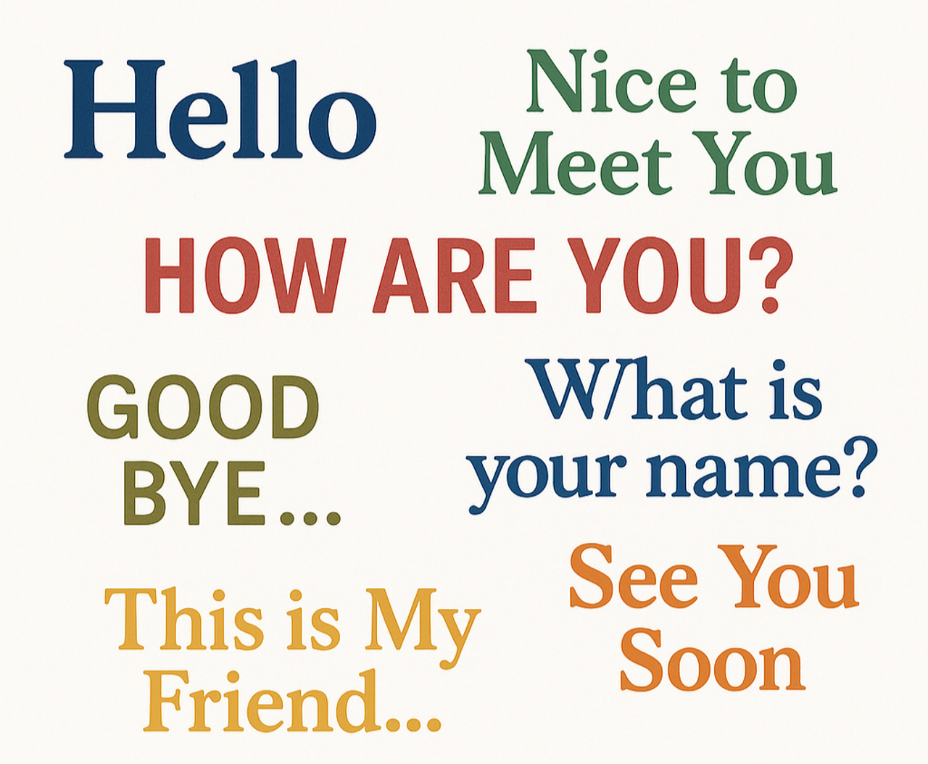

Name: Click or tap here to enter text.

Date: Click or tap here to enter text.
Lesson 1 Vocabulary

- Hello
- Goodbye
- Name
- Please
- Thank you
- Excuse me
- How
- What
- Who
- Nice
- Meet
- Speak

Story 1: Hello, My Name Is Ana

Ana is new.
She goes to class.
She sees a man.
She says, “Hello.”
The man says, “Hello. What is your name?”
Ana says, “My name is Ana.”
The man says, “Nice to meet you, Ana.”
Ana smiles. “Nice to meet you, too.”
A woman comes in.
Ana says, “Hello.”
The woman says, “Excuse me, who are you?”
Ana says, “My name is Ana.”
The woman says, “Do you speak English?”
Ana says, “Yes, I speak a little.”
Ana says, “Can we sit together?”
The woman says, “Yes!”
Ana says, “Thank you.”
The woman says, “You are welcome.”
At the end of class, Ana says, “Goodbye!”
Everyone says, “Goodbye, Ana!”

Comprehension Questions – Story 1

1. What is the woman’s name? Answer: Click or tap here to enter text.
a) Hello
b) Ana
c) Speak
2. What does Ana say first? Answer: Click or tap here to enter text.
a) Thank you
b) Nice
c) Hello
3. What does the man ask Ana? Answer: Click or tap here to enter text.
a) Do you speak English?
b) What is your name?
c) How are you?
4. What does Ana ask the woman? Answer: Click or tap here to enter text.
a) Goodbye
b) Please help me
c) Can we sit together?
5. What do the people say at the end of class? Answer: Click or tap here to enter text.
a) Excuse me
b) Nice to meet you
c) Goodbye Ana

Story 2: Ana Starts Class

Ana is new to town.
She is going to her first English class today.
At the door, she sees a man.
Ana says, “Hello.”
The man smiles and says, “Hello. What is your name?”
Ana answers, “My name is Ana.”
The man says, “It’s nice to meet you, Ana.”
Ana replies, “Nice to meet you, too. What is your name?”
The man says, “William, but my friends call me Bill.”
Anna replies, “Then I will call you Bill.”
In the classroom, a woman walks in.
Ana says, “Hello.”
The woman says, “Excuse me, who are you?”
Ana says, “My name is Ana. I am new.”
The woman asks, “Do you speak English?”
Ana says, “Yes, I speak a little.”
Ana says, “What is your name?”
The woman smiles and says, “Mary. Do you want to sit together?”
Ana says, “Yes! Thank you.”
The woman says, “You’re welcome.”
At the end of the class, Ana waves and says, “Goodbye, Mary! Goodbye, Bill!”
The other students say, “Goodbye, Ana!”

Comprehension Questions – Story 2

1. Where is Ana going? Answer: Click or tap here to enter text.
a) To the park
b) To an English class
c) To work
2. What does Ana say first when she meets the man? Answer: Click or tap here to enter text.
a) Goodbye
b) What is your name?
c) Hello
3. What does the man say to Ana? Answer: Click or tap here to enter text.
a) Nice to meet you
b) Please help me
c) I don’t speak English
4. What does Ana say to ask for help? Answer: Click or tap here to enter text.
a) Who are you?
b) Thank you
c) Please help me
5. What do the students say at the end? Answer: Click or tap here to enter text.
a) Hello Ana
b) Goodbye Ana
c) What is your name?

Vocabulary Dictionary
New Word | Meaning
Click or tap here to enter text. | Click or tap here to enter text.
Click or tap here to enter text. | Click or tap here to enter text.
Click or tap here to enter text. | Click or tap here to enter text.
Click or tap here to enter text. | Click or tap here to enter text.
Click or tap here to enter text. | Click or tap here to enter text.
Click or tap here to enter text. | Click or tap here to enter text.
Click or tap here to enter text. | Click or tap here to enter text.
Click or tap here to enter text. | Click or tap here to enter text.
Click or tap here to enter text. | Click or tap here to enter text.
Click or tap here to enter text. | Click or tap here to enter text.
Click or tap here to enter text. | Click or tap here to enter text.
Click or tap here to enter text. | Click or tap here to enter text.
Click or tap here to enter text. | Click or tap here to enter text.
Click or tap here to enter text. | Click or tap here to enter text.
Click or tap here to enter text. | Click or tap here to enter text.
Click or tap here to enter text. | Click or tap here to enter text.
Click or tap here to enter text. | Click or tap here to enter text.
Click or tap here to enter text. | Click or tap here to enter text.

Conversation Template Name: Click or tap here to enter text.
Date: Click or tap to enter a date.
Name
Click or tap here to enter text. | Click or tap here to enter text.
Click or tap here to enter text. | Click or tap here to enter text.
Click or tap here to enter text. | Click or tap here to enter text.
Click or tap here to enter text. | Click or tap here to enter text.
Click or tap here to enter text. | Click or tap here to enter text.
Click or tap here to enter text. | Click or tap here to enter text.
Click or tap here to enter text. | Click or tap here to enter text.
Click or tap here to enter text. | Click or tap here to enter text.
Click or tap here to enter text. | Click or tap here to enter text.
Click or tap here to enter text. | Click or tap here to enter text.
Click or tap here to enter text. | Click or tap here to enter text.
Click or tap here to enter text. | Click or tap here to enter text.
Click or tap here to enter text. | Click or tap here to enter text.
Find Someone Who… Lingo
Can speak another language  Click or tap here to enter text. | Volunteers for a charity  Click or tap here to enter text. | Has a little sister  Click or tap here to enter text. | Has seen a bear  Click or tap here to enter text. | Likes to walk  Click or tap here to enter text.
Has a pet  Click or tap here to enter text. | Can drive  Click or tap here to enter text. | Has a child  Click or tap here to enter text. | Has flown on a plane  Click or tap here to enter text. | Is wearing black  Click or tap here to enter text.
Is wearing red  Click or tap here to enter text. | Has an earring  Click or tap here to enter text. |  | Has a big brother  Click or tap here to enter text. | Can swim  Click or tap here to enter text.
Has seen a moose  Click or tap here to enter text. | Plays a sport  Click or tap here to enter text. | Has went fishing  Click or tap here to enter text. | Can whistle  Click or tap here to enter text. | Has a hobby  Click or tap here to enter text.
Has eaten pizza  Click or tap here to enter text. | Played a board game  Click or tap here to enter text. | Has broken a bone  Click or tap here to enter text. | Is wearing blue  Click or tap here to enter text. | Likes hockey  Click or tap here to enter text.

